GOKARAJU RANGARAJU

INSTITUTE OF ENGINEERING AND TECHNOLOGY

(Autonomous)

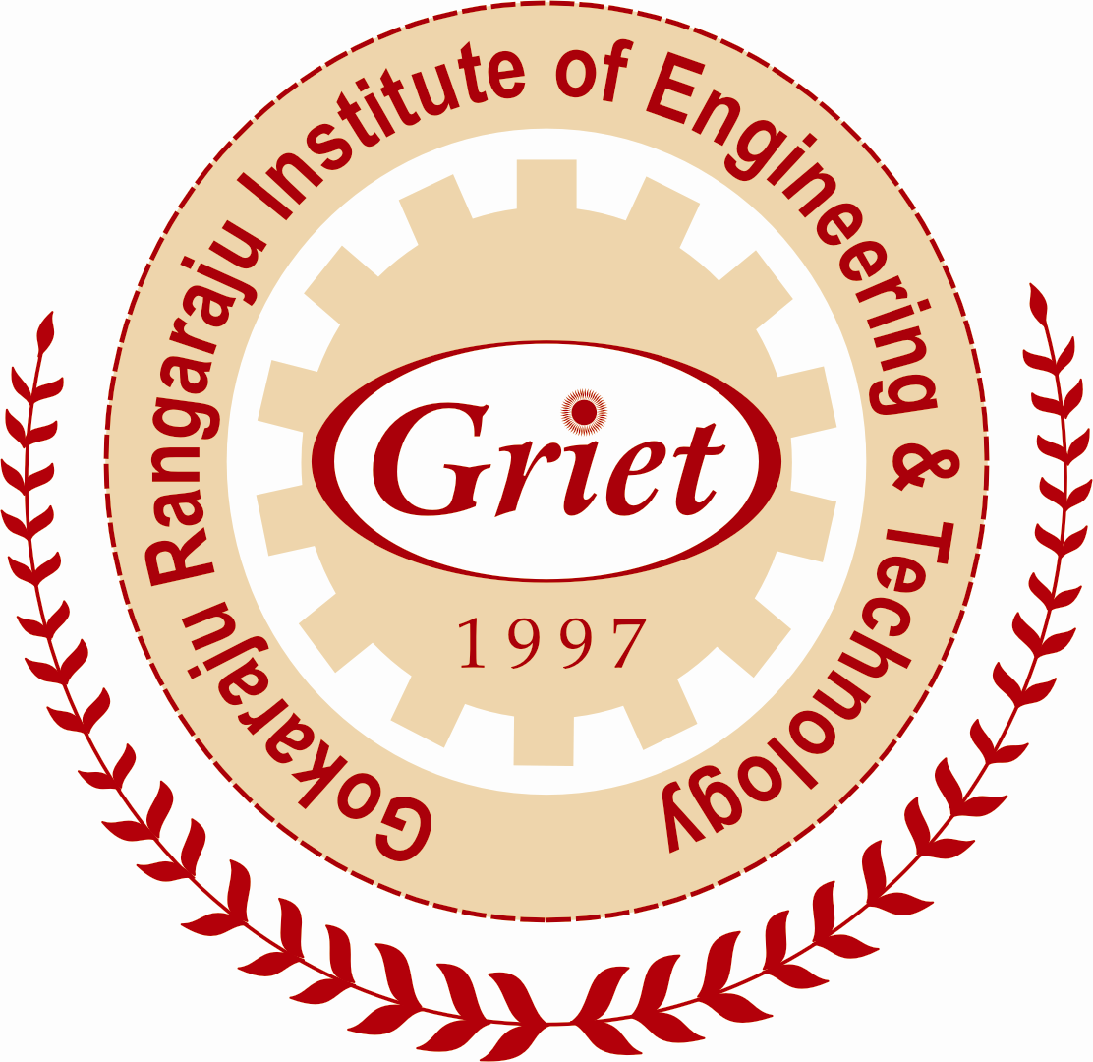

Internal Quality Assurance Cell (IQAC) and

Submission of Annual Quality Assurance Report (AQAR)

2016 - 17

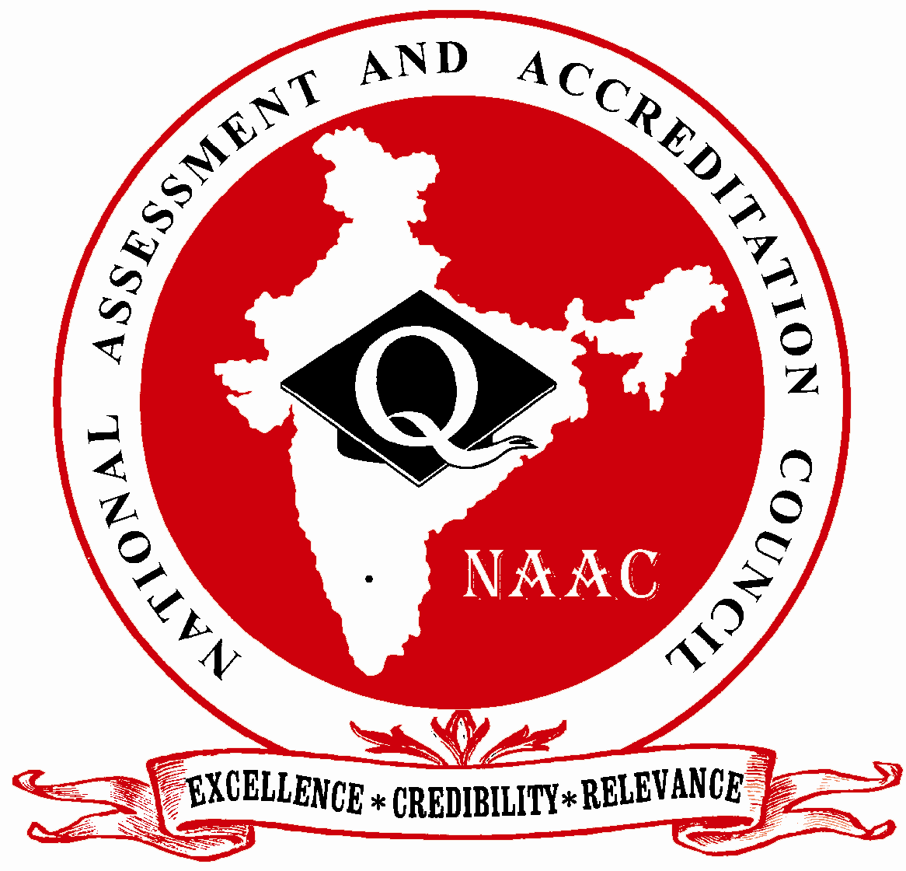

NATIONAL ASSESSMENT AND ACCREDITATION COUNCIL
An Autonomous Institution of the University Grants Commission
P. O. Box. No. 1075, Opp: NLSIU, Nagarbhavi, Bangalore - 560 072 India
The Annual Quality Assurance Report (AQAR) of the IQAC

All NAAC accredited institutions will submit an annual self-reviewed progress report to NAAC, through its IQAC. The report is to detail the tangible results achieved in key areas, specifically identified by the institutional IQAC at the beginning of the academic year. The AQAR will detail the results of the perspective plan worked out by the IQAC. (Note: The AQAR period would be the Academic Year. For example, July 1, 2012 to June 30, 2013)

Part – A
1. Details of the Institution
Gokaraju Rangaraju Institute of Engineering and Technology
1.1 Name of the Institution
Bachupally
1.2 Address Line 1
Kukatpally

Address Line 2
Hyderabad

City/Town
Telangana
State
500090
Pin Code
info@griet.ac.in

Institution e-mail address
+9140 65864440, +9140 65864441

Contact Nos.
Dr Jandhyala N Murthy

Name of the Head of the Institution:
+91 40 65864440

Tel. No. with STD Code:
+91 9652313434

Mobile:

Dr J.Sridevi

Name of the IQAC Co-ordinator:
+91 9989168838

Mobile:
iqac@griet.ac.in

IQAC e-mail address:
APCOGN15432

1.3 NAAC Track ID (For ex. MHCOGN 18879)

1.4 NAAC Executive Committee No. & Date:
EC/64/A&A/28 dated 08-7-2013

(For Example EC/32/A&A/143 dated 3-5-2004.
This EC no. is available in the right corner- bottom
of your institution’s Accreditation Certificate)

www.griet.ac.in

1.5 Website address:
www.griet.ac.in\files\AQAR16-17.doc

Web-link of the AQAR:
For ex. http://www.ladykeanecollege.edu.in/AQAR2012-13.doc
1.6 Accreditation Details
Sl. No. | Cycle | Grade | CGPA | Year of Accreditation | Validity Period
1 | 1st Cycle | A | 3.15 | 2013 | 5 years
2 | 2nd Cycle
3 | 3rd Cycle
4 | 4th Cycle

1.7 Date of Establishment of IQAC : DD/MM/YYYY
01/08/2013

2016-17
1.8 AQAR for the year (for example 2010-11)

1.9 Details of the previous year’s AQAR submitted to NAAC after the latest Assessment and Accreditation by NAAC ((for example AQAR 2010-11submitted to NAAC on 12-10-2011)
- AQAR _AQAR2013-14 submitted to NAAC on 08/08/2014 (DD/MM/YYYY)
- AQAR_ AQAR2014-15 submitted to NAAC on 10/10/2015 (DD/MM/YYYY)
- AQAR_ AQAR2015-16 submitted to NAAC on 08/10/2016 (DD/MM/YYYY)
- AQAR__________________ _______________________ (DD/MM/YYYY)
1.10 Institutional Status

✓

University State Central Deemed Private
✓

Affiliated College Yes No
✓

Constituent College Yes No

Autonomous college of UGC Yes No
✓

✓

Regulatory Agency approved Institution Yes No
(eg. AICTE, BCI, MCI, PCI, NCI)
✓

Type of Institution Co-education Men Women

✓

Urban Rural Tribal

✓

✓

Financial Status Grant-in-aid UGC 2(f) UGC 12B

Grant-in-aid + Self Financing Totally Self-financing

✓

1.11 Type of Faculty/Programme

Arts Science Commerce Law PEI (Phys Edu)

TEI (Edu) Engineering Health Science Management

✓

Others (Specify)

1.12 Name of the Affiliating University (for the Colleges)
Jawaharlal Nehru Technological University Hyderabad

1.13 Special status conferred by Central/ State Government-- UGC/CSIR/DST/DBT/ICMR etc
UGC
Autonomy by State/Central Govt. / University

University with Potential for Excellence UGC-CPE

DST Star Scheme UGC-CE

UGC-Special Assistance Programme DST-FIST

SIRO Recognition
UGC-Innovative PG programmes Any other (Specify)

UGC-COP Programmes
2. IQAC Composition and Activities
9
2.1 No. of Teachers
2
2.2 No. of Administrative/Technical staff
2
2.3 No. of students
2.4 No. of Management representatives

1
2.5 No. of Alumni
2. 6 No. of any other stakeholder and

community representatives
2.7 No. of Employers/ Industrialists
1
1
2.8 No. of other External Experts
2.9 Total No. of members
16
2.10 No. of IQAC meetings held 09
2
3
2.11 No. of meetings with various stakeholders: No. Faculty
2
1
1
Non-Teaching Staff Students Alumni Others

✓

2.12 Has IQAC received any funding from UGC during the year? Yes No

If yes, mention the amount
2.13 Seminars and Conferences (only quality related)
(i) No. of Seminars/Conferences/ Workshops/Symposia organized by the IQAC
1

1
Total Nos. International National State Institution Level
All Departmental Domains
(ii) Themes

2.14 Significant Activities and contributions made by IQAC
- Performance improvement of weak students by counselling and mentoring.
- Organising seminars, conferences, workshops for skill improvement.
- Conducting co and extracurricular activities for overall development of students.
- Providing Career guidance and training for improving placements.
- Organizing FDPs Encouraging Research activities and industry interactive programs.

2.15 Plan of Action by IQAC/Outcome
The plan of action chalked out by the IQAC in the beginning of the year towards quality
enhancement and the outcome achieved by the end of the year *

Plan of Action | Achievements
Staff and students were motivated through meetings and various activities | Improvement in  - Placements  - Results  - Research Funding  - Higher Education
* Attach the Academic Calendar of the year as Annexure.
2.15 Whether the AQAR was placed in statutory body Yes No

✓

Management Syndicate Any other body
Provide the details of the action taken
Action Taken Report was ratified and IQAC started functioning, monitoring the progress of the Institute

Part – B
Criterion – I

1. Curricular Aspects

1.1 Details about Academic Programmes
Level of the Programme | Number of existing Programmes | Number of programmes added during the year | Number of self-financing programmes | Number of value added / Career Oriented programmes
PhD
PG | 09 |  | 09
UG | 06 |  | 06
PG Diploma
Advanced Diploma
Diploma
Certificate
Others
Total | 15 |  | 15

Interdisciplinary
Innovative | MSME

1.2 (i) Flexibility of the Curriculum: CBCS/Core/Elective option / Open options
(ii) Pattern of programmes:
Pattern | Number of programmes
Semester | 15
Trimester
Annual

✓

✓

✓

✓

1.3 Feedback from stakeholders* Alumni Parents Employers Students
(On all aspects)
✓

✓

Mode of feedback : Online Manual Co-operating schools (for PEI)
*Please provide an analysis of the feedback in the Annexure

1.4 Whether there is any revision/update of regulation or syllabi, if yes, mention their salient aspects.
BOS of each program contains members from Industry and Academics. Revision is continuous. Frequency is usually 3 Years. Feedback from alumni and industry is the basis for revision.

1.5 Any new Department/Centre introduced during the year. If yes, give details.
---

Criterion – II
2. Teaching, Learning and Evaluation
2.1 Total No. of permanent faculty
Total | Asst. Professors | Associate Professors | Professors | Others
373 | 270 | 59 | 44
67
2.2 No. of permanent faculty with Ph.D.
2.3 No. of Faculty Positions Recruited (R) and Vacant (V) during the year
Asst. Professors |  | Associate Professors |  | Professors |  | Others |  | Total
R | V | R | V | R | V | R | V | R | V
66 | 50 | 4 |  | 01
--
--
---
2.4 No. of Guest and Visiting faculty and Temporary faculty
2.5 Faculty participation in conferences and symposia:

No. of Faculty | International level | National level | State level
Attended Seminars/ Workshops | 15 | 12
Presented papers | 73 | 4
Resource Persons | 03 | 10 | 25

2.6 Innovative processes adopted by the institution in Teaching and Learning:
Advanced Teaching aids are provided for every department. More emphasis on practical skills, Remedial classes for weak students, Workshop for skill development, EDP competitions/Lectures for innovative skills, Guest lectures, Career guidance for placements.

2.7 Total No. of actual teaching days
192
during this academic year
2.8 Examination/ Evaluation Reforms initiated by
Examination web portal to serve students
the Institution (for example: Open Book Examination, Bar Coding,
Double Valuation, Photocopy, Online Multiple Choice Questions)

2.9 No. of faculty members involved in curriculum
40
40
376
restructuring/revision/syllabus development
as member of Board of Study/Faculty/Curriculum Development workshop
2.10 Average percentage of attendance of students
88%

2.11 Course/Programme wise
distribution of pass percentage :

Title of the Programme | Total no. of students appeared | Division
Title of the Programme | Total no. of students appeared | Distinction % | I % | II % | III % | Pass %
CE | 130 | 63 | 24 | 5 | 0 | 87.87
EEE | 140 | 91 | 26 | 4 | 0 | 91.94
ME | 200 | 126 | 39 | 5 | 0 | 93.46
ECE | 279 | 174 | 74 | 4 | 0 | 89.5
CSE | 259 | 152 | 66 | 3 | 0 | 90.29
IT | 114 | 65 | 20 | 6 | 0 | 88.37
BME | 19 | 12 | 4 | 0 | 0 | 84.29
BT | 25 | 13 | 8 | 0 | 0 | 85.62
TOTAL | 1166 | 696 | 261 | 27 | 0

2.12 How does IQAC Contribute/Monitor/Evaluate the Teaching & Learning processes :
CO- PO mappings
2.13 Initiatives undertaken towards faculty development
Faculty / Staff Development Programmes | Number of faculty  benefitted
Refresher courses | 40
UGC – Faculty Improvement Programme | 35
HRD programmes | 20
Orientation programmes | 50
Faculty exchange programme | 5
Staff training conducted by the university | 50
Staff training conducted by other institutions | 150
Summer / Winter schools, Workshops, etc. | 250
Others

2.14 Details of Administrative and Technical staff
Category | Number of Permanent  Employees | Number of Vacant  Positions | Number of permanent positions filled during the Year | Number of positions filled temporarily
Administrative Staff | 49 |  | 4
Technical Staff | 49 |  | 6
Criterion – III
3. Research, Consultancy and Extension
3.1 Initiatives of the IQAC in Sensitizing/Promoting Research Climate in the institution
Faculty are encouraged to apply for minor and major projects under UGC, AICTE, DST, DBT, ICMR, ICAR etc. They were encouraged to do innovative products and file patents. Faculty were motivated to pursue their Ph.D’s

3.2 Details regarding major projects
 | Completed | Ongoing | Sanctioned | Submitted
Number | - | 1 | 1 | -
Outlay in Rs. Lakhs | - | 20.7 | 20.7 | -

3.3 Details regarding minor projects
 | Completed | Ongoing | Sanctioned | Submitted
Number | - | 4 | 4 | -
Outlay in Rs. Lakhs | - | 6,55,000 | 6,55,000 | -

3.4 Details on research publications
 | International | National | Others
Peer Review Journals | 107 | - | -
Non-Peer Review Journals | 13 | - | -
e-Journals
Conference proceedings | 73 | 16 | -

3.5 Details on Impact factor of publications:
≤3
<2.5
<1
2
Range Average h-index Nos. in SCOPUS

3.6 Research funds sanctioned and received from various funding agencies, industry and other organisations
Nature of the Project | Duration  Year | Name of the  funding Agency | Total grant  sanctioned | Received
Major projects | 2016-17 | UGC/AICTE/DST/  BRNS/ARNDB | 13,703,300 | 20.7
Minor Projects | 2016-17 | UGC | 6,55,000 | 6,55,000
Interdisciplinary Projects
Industry sponsored
Projects sponsored by the University/ College
Students research projects
(other than compulsory by the University)
Any other(Specify)
Total
26, 62, 000/-

3.7 No. of books published i) With ISBN No. Chapters in Edited Books
3
2

ii) Without ISBN No.
3.8 No. of University Departments receiving funds from
UGC-SAP CAS DST-FIST
✓

DPE DBT Scheme/funds
3.9 For colleges Autonomy CPE DBT Star Scheme

INSPIRE CE Any Other (specify)

3.10 Revenue generated through consultancy
3.11 No. of conferences organized by the Institution
Level | International | National | State | University | College
Number | 1 | 2
Sponsoring agencies | GRIET | TEQIP

20
3.12 No. of faculty served as experts, chairpersons or resource persons
4
3

3.13 No. of collaborations International National Any other
7
3.14 No. of linkages created during this year
3.15 Total budget for research for current year in lakhs :
27.52 L
122.99 L
From Funding agency From Management of University/College
Total
150.51 L

3.16 No. of patents received this year
Type of Patent |  | Number
National | Applied | 1
National | Granted | 1
International | Applied
International | Granted
Commercialised | Applied
Commercialised | Granted

3.17 No. of research awards/ recognitions received by faculty and research fellows
Of the institute in the year
Total | International | National | State | University | Dist | College
2 |  | 1 | 1

3.18 No. of faculty from the Institution
10
who are Ph. D. Guides
and students registered under them
24

3.19 No. of Ph.D. awarded by faculty from the Institution
13

3.20 No. of Research scholars receiving the Fellowships (Newly enrolled + existing ones)
1
1
JRF SRF Project Fellows Any other

1

3.21 No. of students Participated in NSS events:
200
50
University level State level
National level International level
50

3.22 No. of students participated in NCC events:

1
University level State level
National level International level

3.23 No. of Awards won in NSS:
University level State level

2
National level International level

3.24 No. of Awards won in NCC:
University level State level

National level International level

3.25 No. of Extension activities organized

✓

University forum College forum
✓

✓

NCC NSS Any other

3.26 Major Activities during the year in the sphere of extension activities and Institutional Social Responsibility
- Pragnya, a co-curricular event involving paper and poster presentations, project or product display
- Reudo, a environmental conscious program
- Pulse, a college fest
- Blood donation camp in NSS
- Spirals, A literary activity
- Spices, culinary skills
- Xkernel, a software contest
- Rhythms, an extracurricular event
- Pragnya 90.4 FM Community Radio
- International Yoga day
- Peace day
- Women’s day

Criterion – IV
4. Infrastructure and Learning Resources
4.1 Details of increase in infrastructure facilities:
Facilities | Existing | Newly created | Source of Fund | Total
Campus area | 44011 Sqmt | - | Society | 44011 Sqmt
Class rooms | 6433 | 1513 | Society | 7946
Laboratories | 9702 | - | Society | 9702
Seminar Halls | 1624 | 721 | Society | 2345
No. of important equipments purchased (≥ 1-0 lakh) during the current year. |  |  | Society
Value of the equipment purchased during the year (Rs. in Lakhs) | 487.34 | 247.03 | Society | 734.37
Others

4.2 Computerization of administration and library
Yes, Administration, library, Examination centre were computerised.

4.3 Library services:
 | Existing |  | Newly added |  | Total
 | No. | Value | No. | Value | No. | Value
Text Books | 109841 | 287.92 | 3109 |  | 112950 | 1180200
Reference Books | 12320 | 20.44 | 315 |  | 12635 | 101206
e-Books
Journals | 250 | 10.6 | -- | -- | 242 | 5.8
e-Journals | 6849 | 26.7 | -- | -- | 1996 | 10.9
Digital Database |  |  |  |  | 1 | 10500
CD & Video
Others (specify) |  |  |  |  | NPTEL | 80000

4.4 Technology up gradation (overall)
 | Total Computers | Computer Labs | Internet | Browsing Centres | Computer Centres | Office | Depart-ments | Others
Existing | 1818 | 22 | 65 | 45 | 6 | 40 | 120 | 15
Added | 350 | 14 | 100 | 30 | - | 15 | 25 | -
Total | 2168 | 36 | 165 | 75 | 6 | 55 | 145 | 15

4.5 Computer, Internet access, training to teachers and students and any other programme for technology
upgradation (Networking, e-Governance etc.)
Various FDP’s and ICT workshops were conducted for faculty, and various certification courses on communication, OCJP, OCA, CCNA were offered for the students.

4.6 Amount spent on maintenance in lakhs :
14.38
i) ICT
295.89
ii) Campus Infrastructure and facilities
192.09
iii) Equipments

iv) Others

502.36
Total :

Criterion – V
5. Student Support and Progression
5.1 Contribution of IQAC in enhancing awareness about Student Support Services
Route bus facility, ATM service, Medical facility, Xerox facility, Stores, Gym, Hostel facility, Indoor and outdoor games

5.2 Efforts made by the institution for tracking the progression
Feedback from all stake holders

5.3 (a) Total Number of students
UG | PG | Ph. D. | Others
4686 | 370 | -- | --

(b) No. of students outside the state
510
--
(c) No. of international students

No | %
3329 | 65.85
Men Women
No | %
1727 | 34.15

Last Year |  |  |  |  |  | This Year
General | SC | ST | OBC | Physically Challenged | Total | General | SC | ST | OBC | Physically Challenged | Total
2276 | 535 | 202 | 1944 | 7 | 4964 | 2458 | 509 | 197 | 1882 | 10 | 5056
Demand ratio Dropout %
5.4 Details of student support mechanism for coaching for competitive examinations (If any)
Yes, Campus Training Programs were conducted, Student facility centres were arranged.

700
No. of students beneficiaries
5.5 No. of students qualified in these examinations

89
12
NET SET/SLET GATE CAT
IAS/IPS etc State PSC UPSC Others
1

200

5.6 Details of student counselling and career guidance
All the students along with parents meet career guidance cell and register and take guidance in the beginning of the academic year. Those with less attendance and poor academic performance are monitored by career guidance cells and mentors of the group. Daily attendance will be sent to the parents.

1260
No. of students benefitted

5.7 Details of campus placement
On campus |  |  | Off Campus
Number of Organizations Visited | Number of Students Participated | Number of Students Placed | Number of Students Placed
48 | 782 | 602 | 38

5.8 Details of gender sensitization programmes
Gender sensitization workshop was conducted in JNTUH. Six faculty have attended the workshop. Included as mandatory course in second year.

5.9 Students Activities
5.9.1 No. of students participated in Sports, Games and other events
8
4

State/ University level National level International level

No. of students participated in cultural events
40

State/ University level National level International level

5.9.2 No. of medals /awards won by students in Sports, Games and other events

Sports : State/ University level National level International level

Cultural: State/ University level National level International level

- 2 students won second price in ‘Hackathon’ organized by Trident Group of Institutions CISCO Academy at Vignana Bharathi Institute of Technology, Hyderabad.
- 5 teams participated from our college and secured first and second prizes in "Cisco IoT Hackathon 2017" in its nodal centre, VBIT (Vignana Bharathi Institute of Technology, Hyderabad )

5.10 Scholarships and Financial Support
 | Number of  students | Amount
Financial support from institution | 8 | 43,000
Financial support from government | 2450 | 13,28,57,900
Financial support from other sources | 120 | 6,00,000
Number of students who received International/ National recognitions | 180 | 18,00,000

5.11 Student organised / initiatives
1

Fairs : State/ University level National level International level
1

Exhibition: State/ University level National level International level

8
5.12 No. of social initiatives undertaken by the students

5.13 Major grievances of students (if any) redressed:
- More route buses were requested and provided.
Criterion – VI
6. Governance, Leadership and Management
6.1 State the Vision and Mission of the institution
Vision: To be among the best of the institutions for engineers and technologists with attitudes, skill and knowledge and to become an epicentre of creative solutions.
Mission: To achieve and impart quality education with an emphasis on practical skills and social relevance

6.2 Does the Institution has a management Information System
Yes,
- Accounting Software in Payroll System
- GCAP (GRIET Campus Administrative Portal)

6.3 Quality improvement strategies adopted by the institution for each of the following:
6.3.1 Curriculum Development
- Departmental Advisory Board (DAB) / Board of Studies takes responsibility of preparing curriculum of the program.
- The curriculum for the program is developed by considering PEOs and POs, taking the feedback from industry people regarding their expectations and latest developments in technology through Program Assessment Committee (PAC).
- A benchmark is taken from curricula of JNTUH (affiliating University), premier institutes like IIT, NIT and also from aboard universities.

6.3.2 Teaching and Learning
- Qualified and experienced staff members are recruited through selection process.
- Teaching aids like LCD, ICT were utilised.
- MOOC courses by QEEE,IIT BombayX, IIT Kharagpur, NPTEL, Spoken Tutorials and over 180 faculty are qualified in various courses.

6.3.3 Examination and Evaluation
- Question Paper setting and Evaluation of the Answer Scripts shall be done as per the procedures laid down by the Academic Council of the College as per Bloom’s Taxonomy.
- A 10- point grading system with corresponding letter grades and percentage of marks is implemented.
- There shall be two Mid-Term written examinations during a semester.
- Tutorials are to be conducted, student’s participation and performance are to be observed

6.3.4 Research and Development
- R & D initiatives by conducting meetings, guest lectures by eminent personalities.
- Access to internet, e-journals etc
- Three international journal were published by GRIET.

6.3.5 Library, ICT and physical infrastructure / instrumentation
- All departments have excellent laboratory infrastructural facilities and all the year students are trained in their respective laboratories to enhance their practical skills and also to do their research work requirements.
- Laboratories are equipped with sufficient hardware & licensed software to run program specific curriculum and off program curriculum for their research.
- The Research work is under the guidance of well experienced faculty, lab assistants also.
- Digital library is available for search of papers with free internet facility and with latest journals.
- Digital library access is given to all the students through wifi internet where they can read latest research papers from the IEEE, Elsevier, Science Direct, McGraw Hill and ACM in the college campus.
- Product laboratory is available for faculty and students to carry their innovative products and projects.

6.3.6 Human Resource Management
Administration staff allocated for looking into HR details covering Induction, exit, leave benefits, Attendance, Performance Appraisals, Pay Allowances, Incentives, Promotions etc.,

6.3.7 Faculty and Staff recruitment
- News advertisement, website notifications.
- Screening Resumes and Intimation to the selected candidates.
- Written Test
- Interview by Department experts
- Demonstration and Interview by Management persons
- Ratification by University
- Student Faculty ratio is 15:1
- Cadre ratio is 1:2:6 (1 Professor, 2 Associate Professors, 6 Assistant Professors)
- Qualification, eligibility and pay scale as per the norms of AICTE, UGC

6.3.8 Industry Interaction / Collaboration
- Industrial visits are organized to the students along with the faculty members to bridge the gap between theoretical and practical aspects of the curriculum.
- Experts from industry are invited to interact with the students in every semester.
- Department is having collaborations with reputed industries and professional bodies.
- The institution has MOUs to strengthen the relationships with industry.
- Students are provided and given internship facility with research organizations

6.3.9 Admission of Students
- The candidates who want to seek admission in GRIET have to qualify in the EAMCET (Engineering ,Agricultural and Medical Common Entrance Test ) examination conducted by Govt. of Telangana . The candidates should attend the counselling for admission into the Engineering colleges conducted by the Convenor. Based on the rank obtained in EAMCET, candidates can opt for GRIET as per the availability of the college and branch at the time of counselling. 70% through convenor quota through state administered counselling
- The 30% of NRI Quota is based on merit.
- The Convener of ECET admits 20% of the candidates from the stream of Diploma holders directly in to second year of B.Tech as Lateral Entry
- PG Students joins based on PGCET, GATE and ICET’s
- B.Tech admissions in 2017 is 100% in all category

6.4 Welfare schemes for
Teaching | Provisions for PF, Faculty club, and free transportation facility
Non teaching | E-learning programmes, free food and medical facility, initiatives for good performance and free transportation
Students | Scholarships, medical facility, free food scheme for  Economically backward students. Initiative for good performance in academics and beyond academics.

6.5 Total corpus fund generated
182 L
✓

6.6 Whether annual financial audit has been done Yes No

6.7 Whether Academic and Administrative Audit (AAA) has been done?
Audit Type | External |  | Internal
Audit Type | Yes/No | Agency | Yes/No | Authority
Academic | ✓ | Audit by NPIU | ✓ | Principal
Administrative | ✓ | Audit by NPIU | ✓ | Principal

6.8 Does the University/ Autonomous College declares results within 30 days?
✓

For UG Programmes Yes No
✓

For PG Programmes Yes No
6.9 What efforts are made by the University/ Autonomous College for Examination Reforms?
- Separate examination portal, which supports timely management of exam schedules, results and other related issues.
- End examination question paper setters are from other colleges and Universities
- Coding and decoding of answer scripts in evaluation process
- Evaluation of answer scripts by the Professors of other colleges and Universities
- Recounting and Revaluation facility to student

6.10 What efforts are made by the University to promote autonomy in the affiliated/constituent colleges?
JNTUH sanctioned autonomous status for the institutions which maintain quality. GRIET received autonomous status from 2011-12 which is conferred by UGC for 6 years from 2014 - 15

6.11 Activities and support from the Alumni Association
Alumni association meets once in a year, provides guidance regarding career development.

6.12 Activities and support from the Parent – Teacher Association
- Daily SMS alert to parents about their ward’s attendance.
- Counselling is provided for both parents and students by constant monitoring through career guidance cell and class mentors.

6.13 Development programmes for support staff
- Staff is trained on new equipments or tool by the Vendor
- Training is provided on operation of PCs, Printer, and Scanner
- Training is provided on MS Office, Excel to non-teaching and technical staff members as part of computer literacy program.
- Regular Training is provided to improve soft skills and communication skills.

6.14 Initiatives taken by the institution to make the campus eco-friendly
- Plastic free zone campus initiatives
- Waste recycling and Rain water harvesting modalities
- Environment awareness programs and plantation programs conducted by NSS wing of GRIET
- Replacement of CR is with LED monitors, Introduction of LED lights, and
- Installation of 110 KW solar plant.
- Green campus initiative – Campus is divided in to 8 zones and 8 departments taking care and improving floral .
- Sewage Treatment plant, Solid waste Management, Rain Water harvesting, RO plant for drinking water.

Criterion – VII
7. Innovations and Best Practices
7.1 Innovations introduced during this academic year which have created a positive impact on the functioning of the institution. Give details.
- Career guidance to mentor and monitor for academic excellence.
- MOUs with multinational companies to strengthen the relationships with industry
- Organizing industry oriented work shops.
- Internship facility with research organizations

7.2 Provide the Action Taken Report (ATR) based on the plan of action decided upon at the
beginning of the year
- Attendance of the students has improved.
- Placements and higher studies improved.
- Industry interaction intensified.

7.3 Give two Best Practices of the institution (please see the format in the NAAC Self-study Manuals)
- Emphasis on Industry Collaborations.
- Innovative ideas leading to product development.
- Every project should lead to patent dictum of academic work at GRIET

*Provide the details in annexure (annexure need to be numbered as i, ii,iii)
7.4 Contribution to environmental awareness / protection
- College organizes a special environmental concerned programmes such as “Reudo”, “Harithaharam” which focuses on multiple events connected with environmental protection.
- Green Campus philosophy is implemented

✓

7.5 Whether environmental audit was conducted? Yes No

7.6 Any other relevant information the institution wishes to add. (for example SWOT Analysis)
Strengths
Qualified, experienced, dedicated staff. Well-structured curriculum. Excellent infrastructure facilities. Well-equipped laboratories. Enriched and automated library. Career counselling and Placement cell. Active Mentoring system. Personality Development and communication improvement Programme for all the students. Skill Improvement workshops. Industry oriented projects. Co and Extracurricular activities for overall development. Sponsored research funding Projects. MOUs with Multinational Companies. Students Internships at research organisations.
Weaknesses
English communication gap with students from rural back ground. Challenges regarding training the new faculty.
Opportunities: To introduce new courses with societal and Industry needs. Higher education opportunities in India and Abroad. Approach to Industry awareness. Technical skill Improvements. Industrial consultancy.

8. Plans of institution for next year
- Efforts for skill development and innovative thinking
- Industry collaborated projects and research will be focussed.
- Student support like career guidance will be enhanced.

Name :Dr.J.Sridevi Name : Dr. Jandhyala N Murthy
Coordinator, IQAC Cell Principal & Chairman IQAC Cell
Gokaraju Rangaraju Institute of Gokaraju Rangaraju Institute of
Engineering and Technology (Autonomous) Engineering and Technology (Autonomous)
Bachupally, Kukatpally, Hyderabad, Bachupally, Kukatpally, Hyderabad
Telangana, India - 500090 Telangana , India- 500090

Signature of the Coordinator, IQAC Signature of the Chairperson, IQAC

_______***_______
Annexure I
Abbreviations:
CAS - Career Advanced Scheme
CAT - Common Admission Test
CBCS - Choice Based Credit System
CE - Centre for Excellence
COP - Career Oriented Programme
CPE - College with Potential for Excellence
DPE - Department with Potential for Excellence
GATE - Graduate Aptitude Test
NET - National Eligibility Test
PEI - Physical Education Institution
SAP - Special Assistance Programme
SF - Self Financing
SLET - State Level Eligibility Test
TEI - Teacher Education Institution
UPE - University with Potential Excellence
UPSC - Union Public Service Commission

***************

Annexure II

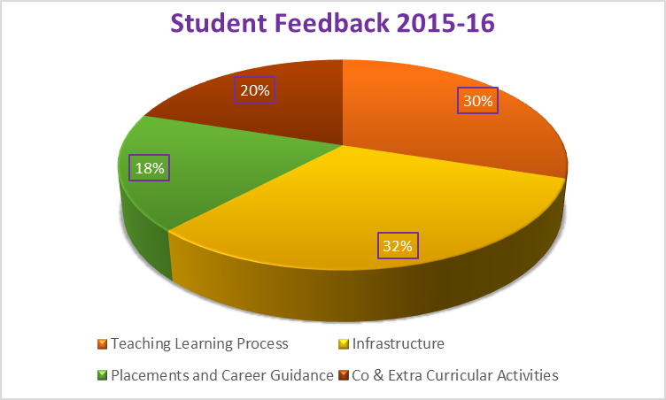

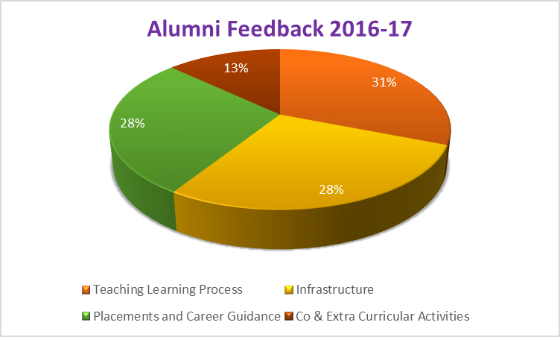

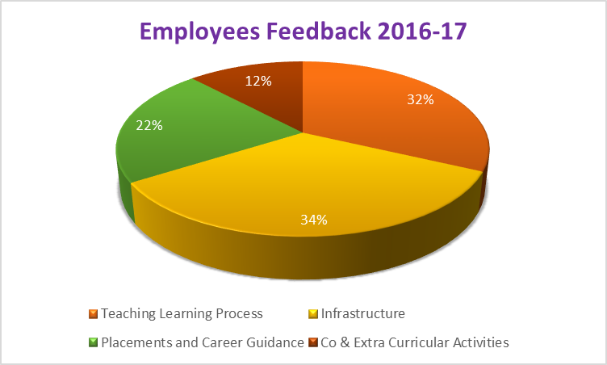

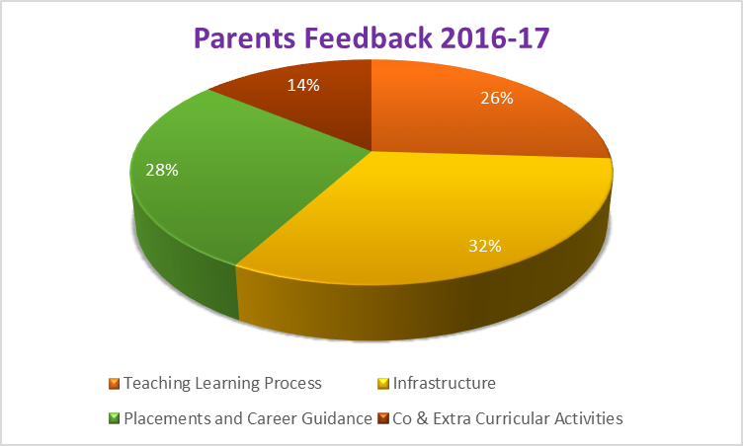

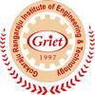

Calendar 2016 - 17

Gokaraju Rangaraju Institute of Engineering and Technology
(Autonomous)
Bachupally, Kukatpally, Hyderabad – 500 090

National Anthem

Jana Gana Mana Adhinayak Jai Hey
Bharat Bhagya Vidhata
Punjab Sindh Gujarat Maratha
Dravid Utkal Banga
Vindhya Himachal Yamuna Ganga
Uchchal Jaladhi Taranga
Tab Shubha Name Jage
Tab Shubh Ashish Mange Gaye
Tab Jaya Gatha
Jana Gana Mangal Dayak Jaya Hey
Bharat Bhagya Vidhata
Jaya Hey, Jaya Hey, Jaya Hey
Jaya, Jaya, Jaya, Jaya Hey

About us
GRIET is one of the premier engineering colleges, imparting quality technical education to the students, drawn from competitive examinations, conducted by the Government of Telangana. The Institute is located in a sprawling campus with buildings, architectural masterpieces, built on a hillock, on Nizampet Road, just 4 km from JNTUH, Kukatpally, Hyderabad. The Institute was established in the year 1997 by Dr. G. Gangaraju in fond memory of his father, Late Sri Gokaraju Rangaraju, a crusader in the field of education. Dr. G Gangaraju is the Chairman, Laila Group of Industries, with multi-faceted interests in Pharmaceuticals, Paper, Software, Agro Industries and Exports.

Attendance & Promotion Rules
GRIET follows the Attendance & Promotion rules as summarized below: Shortage of attendance in aggregate up to 10% (65% and above and below 75%) in each semester or 1 year to be condoned by the Vice-Chancellor on the recommendations of the Sub-Committee of the Academic Senate on valid and genuine grounds.
A student shall be promoted from one class to the next only if he/she fulfills the academic requirements of credits from regular and supplementary examinations, as laid down by Academic Regulations applicable for that batch of admission.

GRIET Code of Conduct

All the students of GRIET should abide by the provisions of the following Code of Conduct.
- The student of GRIET should display exemplary conduct and character, not only within the Campus but also outside.
- The student should be regular to the classes and should conduct with dignity and decorum, befitting to a professional.
- The student should be conscious of cleanliness and hygiene.
- The student should respect teaching and non-teaching staff.
- The student should feel a sense of belonging and accordingly protect the furniture, class room & laboratory equipment and library books.
- The student of GRIET should not disturb the peace, serenity and academic life of the Campus.
- The College premises and buildings should be kept clean. Writing of any nature and sticking of posters and notices on the buildings or walls are strictly prohibited.
- Any student(s) responsible for bringing outside elements into the Campus for creating law and order problems will be severely dealt with.
- Eve-teasing on the Campus is severely punishable.
- Ragging in any form to any extent is strictly prohibited.

Violation of any of the above guidelines will invite fine, suspension or dismissal.

Important Telephone Numbers
GRIET Board Telephone Numbers: 040-65864440, 4441
Director | 9848042315 | Accounts | 9885056567
Principal | 9391184994 | Scholarships | 9908955788
Vice Principal (1st Year) | 9959088873 | Exam Section | 9849078370
Senior AO | 9949655559 | Transport | 8897264644
AO | 9866911379 | Library | 9849577602
Coordinator (NSS) | 9246353240 | PD (sports) | 9440084845
Canteen | 9949903710 | Gate (Security) | 8008736934

Organization Chart

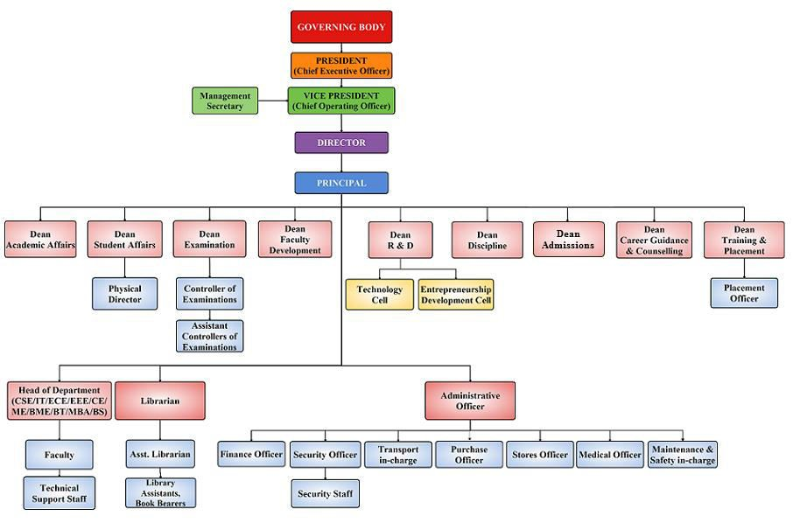

Deans

Academics | Dr. K. Anuradha Tel No: 9440619039
Examinations | Dr. A. Sai Hanuman Tel No: 9849078370
Research& Development | Dr. Swedish Kumar Singh Tel No: 9866747605
Training & Placements | Dr. K. V. S. Raju Tel No : 9949655559
Admissions | Dr. Y. Rama Krishna Prasad Tel No: 9849826538
Discipline | Dr. N. Sunil Kumar Tel No: 9885121646
Student Affairs | Dr. P. V. S. Srinivas Tel No: 9866861613
Counselling and Career Guidance | Sri. P. Murali Krishna Tel No: 8008992200
Faculty Development | Dr. K. Prasanna Lakshmi Tel No: 9849547910
Publicity, Alumni Affairs | Dr. L. Jayahari Tel No: 9866857903
Finishing School & Outreach | Dr. V. N. Rama Devi Tel No: 9490145046
Incubation Centre | Dr. D. Sailaja Tel No: 9704137989

Head of the Departments

ECE | Dr. T. C. Sharma Tel No: 9849219175
EEE | Dr. J. Praveen Tel No: 9440381885
BME | Dr. T. Padma Tel No: 9246353240
CSE | Dr. Ch. Mallikarjuna Rao Tel No: 9849274032
IT | Dr. Y. Vijayalata Tel No: 9949852992
ME | Dr. L. Jayahari Tel No: 9866857903
CE | Dr. Md. Hussain Tel No: 9963880472
BT | Dr. N. Sunil Kumar Tel No: 9885121646
BS | Dr. S. Ramamurthy Tel No: 9959088873
MCA | Dr. Sk. Altaf Hussain Basha Tel No: 9441537780
MBA | Dr. D. Indira  Tel No: 9966016412

Coordinators

B. Tech (CCC) | Mr. C. Srikanth, Asst. Prof. (BT)
College Diary | Ms. K. Lakshmi Sushma, Asst. Prof. (IT)
TASK | Mr. N. V. Ganapathi Raju, Assoc. Prof (MCA)
Faculty Club | Ms. G. Sandhya Rani, Asst. Prof. (EEE)
FSW | Dr. K. Prasanna Lakshmi, Assoc. Prof. (IT)
GRIP | Ms. V. Sowmya, Assoc. Prof. (CSE)
GRIET Alumni Association | Ms.G. Swapna, Asst. Prof. (EEE)
Gaming Club | Mr. P.K. Abhilash, Asst. Prof (IT)
Robotic Club | Mr. Y. J. Nagendra Kumar, Assoc. Prof. (IT)
Technology Cell | Dr. N. Sateesh, Prof. (Mech)
Web Page | Mr. N. V. Ganapathi Raju, Assoc.Prof. (MCA)
Women Development Cell | Ms. V. N. Rama Devi, Asst. Prof. (BS)
M. Tech | Mr. K. Jamal, Asst. Prof (ECE)

Coordinators of Co-curricular & Extra Curricular Activities

No | Activity | Coordinator
1 | NSS | BME
2 | Annual Day | CSE
3 | Graduation Day | ME
4 | Pragnya | College Committee
5 | Pulse | College Committee
6 | Quizzicals | MBA
7 | Reflections | BS
8 | Rhythms | IT
9 | Scientific Forestep | EEE
10 | Souvenir | Admin
11 | Spices | BT
12 | Spirals | EEE
13 | Sports & Games | PD
14 | XKernal | MCA

Committees and Professional Bodies

No | Committee | Chairman
1 | Editorial Committee | Ms. R. Lakshmi Kanthi, Asst. Prof. (BS)
2 | Library Committee | Dr. V. Ayyampillai, Prof. (ECE)
3 | Canteen Committee | Mr. B. Ravi Kiran, Asst. Prof. (BS)
4 | Transport Committee | Mr. K. Siva Satya Mohan, Asst. Prof. (MECH)
5 | Time Table Committee | Ms. B. Rupa, Asst. Prof. (CSE)
6 | e-Resources Committee | Dr. K. Madhavi, Prof. (CSE)

No | Professional Bodies | In charge Department
1 | CSI | CSE
2 | IEEE | IT
3 | ISTE | IT
4 | SAE | ME
5 | ICI | CE
6 | SME | ME
7 | IE | CE
8 | BMSI | BME
9 | IETE | ECE
10 | HMA | MBA
11 | AIMS | MBA

Revised Academic Calendar: Academic year 2016-17

I - B. Tech. – First Semester

S. No | Event | Period | Duration
1 | Orientation Day | 04-08-2016
2 | 1st Spell of Instructions | 04-08-2016 to 05-10-2016 | 9 weeks
3 | 1st Mid-term Examination | 06-10-2016 to 12-10-2016 | 1 week
4 | 2nd Spell of Instructions | 13-10-2016 to 30-11-2016 | 7 weeks
5 | 2nd Mid-term Examination | 01-12-2016 to 07-12-2016 | 1 week
6 | Preparation | 08-12-2016 to 14-12-2016 | 1 week
7 | End Semester& Practical Examinations | 15-12-2016 to 04-01-2017 | 3 weeks
8 | Commencement of II Semester, A.Y. 2016-17 | 05-01-2017

I - B. Tech. – Second Semester

S. No | Event | Period | Duration
1 | 1st Spell of Instruction | 05-01-2017 to 11-03-2017 | 9 weeks
2 | 1st Mid-term Examination | 13-03-2017 to 18-03-2017 | 1 week
3 | 2nd Spell of Instruction | 20-03-2017 to 10-05-2017 | 8 weeks
4 | 2nd Mid-term Examination | 11-05-2017 to 17-05-2017 | 1 week
5 | Preparation | 18-05-2017 to 24-05-2017 | 1 week
7 | End Semester & Practical Exams | 25-05-2017 to 14-06-2017 | 3 weeks
8 | Summer Vacation | 15-06-2017 to 18-06-2017
9 | Commencement of First Semester, A.Y.2017-2018 | 19-06-2017

II, III & IV - B. Tech. – First Semester

S. No | Event | Period | Duration
1 | 1st Spell of Instructions | 27-06-2016 to 27-08-2016 | 9 Weeks
2 | 1st Mid-term Examinations | 29-08-2016 to 03-09-2016 | 1 Week
3 | Supplementary Examinations | 05-09-2016 to 17-09-2016 | 2 Weeks
4 | 2nd Spell of Instructions | 19-09-2016 to 05-11-2016 | 7 Weeks
5 | 2nd Mid-term Examinations | 07-11-2016 to 12-11-2016 | 1 Week
6 | Preparation | 14-11-2016 to 19-11-2016 | 1 Week
7 | End Semester Examinations (Theory/ Practicals) | 21-11-2016 to 10-12-2016 | 3 Weeks
8 | Commencement of Second Semester, A.Y 2016-17 | 12-12-2016 (Monday)

II, III & IV - B. Tech. – Second Semester

S. No | Event | Period | Duration
1 | 1st Spell of Instruction | 12-12-2016 to 11-02-2017 | 9 Weeks
2 | 1st Mid-term Examinations | 13-02-2017 to 18-02-2017 | 1 Week
3 | Supplementary Examinations | 20-02-2017 to 04-03-2017 | 2 Weeks
4 | 2nd Spell of Instruction | 06-03-2017 to 22-04-2017 | 7 Weeks
5 | 2nd Mid-term Examinations | 24-04-2017 to 29-04-2017 | 1 Week
6 | Preparation | 01-05-2017 to 06-05-2017 | 1 Week
7 | End Semester Examinations | 08-05-2017 to 27-05-2017 | 3 Weeks
8 | Summer Vacation | 29-05-2017 to 17-06-2017 | 3 Weeks
9 | Commencement of First Semester, A.Y 2017-18 | 19-06-2017

M. Tech. First Year – First Semester

S. No | Event | Period | Duration
1 | Orientation Program | 19-09-2016
2 | I Spell of Instructions | 19-09-2016 to 19-11-2016 | 9 Weeks
3 | I Mid Examinations | 21-11-2016 to 26-11-2016 | 1 Week
4 | II Spell of Instructions | 28-11-2016 to 21-01-2017 | 8 Weeks
5 | II Mid Examinations | 23-01-2017 to 28-01-2017 | 1 Week
6 | Preparation and Practical Examinations | 30-01-2017 to 04-02-2017 | 1 Week
7 | End Semester Examinations | 06-02-2017 to 18-02-2017 | 2 Weeks
8 | Commencement of II Semester, A. Y. 2016-17 | 20-02-2017

M. Tech. First year – Second Semester

S. No | Event | Period | Duration
1 | I Spell of Instructions | 20-02-2017 to 22-04-2017 | 9 Weeks
2 | I Mid Examinations | 24-04-2017 to 29-04-2017 | 1 Week
3 | II Spell of Instructions | 01-05-2017 to 20-05-2017 | 3 Weeks
4 | Summer Vacation | 22-05-2017 to 24-06-2017 | 5 Weeks
5 | II Spell of Instructions | 26-06-2017 to 29-07-2017 | 5 Weeks
6 | II Mid Examinations | 31-07-2017 to 05-08-2017 | 1 Week
7 | Preparation and Practical Exams | 07-08-2017 to 12-08-2017 | 1Week
8 | End Semester Examinations | 14-08-2017 to 26-08-2017 | 2 Weeks
9 | Commencement of A.Y 2017-18 | 28-08-2017

M. Tech. Second year – First Semester

S. No | Event | Period | Duration
1 | Spell of Instructions | 28-08-2017 to 06-01-2018 | 19 Weeks
2 | Project work Registrations | 28-08-2017 to 02-09-2017
3 | Seminar/ Comprehensive Viva | 23-10-2017 to 28-10-2017

M. Tech. Second year – Second Semester

S. No | Event | Period | Duration
1 | Spell of Instructions | 08-01-2018 to 26-05-2018 | 20 Weeks
2 | Thesis Submission duration | 28-05-2018 to 10-11-2018 | 24 Weeks

MCA Third year – First Semester

S. No | Event | Period | Duration
1 | I Unit of Instructions | 08-08-2016 to 24-09-2016 | 7 Weeks
2 | I Mid Examinations | 26-09-2016 to 01-10-2016 | 1 Week
3 | II Unit of Instructions | 03-10-2016 to 03-12-2016 | 9 Weeks
4 | II Mid Examinations | 05-12-2016 to 10-12-2016 | 1 Week
5 | Preparation and Practical Examinations | 12-12-2016 to 17-12-2016 | 1 Week
6 | End Semester Examinations | 19-12-2016 to 31-12-2016 | 2 Weeks
7 | Commencement of II Semester | 02-01-2017

MCA Third year – Second Semester

S. No | Event | Period | Duration
1 | Project Work | 02-01-2017 to 27-05-2017 | 21 Weeks
2 | Viva-Voce | 29-05-2017 to 10-06-2017 | 2 Weeks

MBA Second year – First Semester

S. No | Event | Period | Duration
1 | I Unit of Instructions | 22-08-16 to 15-10-16 | 8 Weeks
2 | I Mid Examinations | 17-10-16 to 22-10-16 | 1 Week
2 | II Unit of Instructions | 24-10-16 to 17-12-16 | 8 Weeks
3 | II Mid Examinations | 19-12-16 to 24-12-16 | 1 Week
4 | Preparation and Practical Examinations | 26-12-16 to 31-12-16 | 1 Week
7 | End Semester Examinations | 02-01-17 to 14-01-17 | 2 Weeks
8 | Commencement of II Year II Sem | 16-01-2017

MBA Second year – Second Semester

S. No | Event | Period | Duration
1 | I Unit of Instructions | 16-01-17 to 11-03-17 | 8 Weeks
2 | I Mid Examinations | 13-03-17 to 18-03-17 | 1 Week
3 | II Unit of Instructions | 20-03-17 to 29-04-17 | 6 Weeks
4 | Summer Vacation | 01-05-17 to 03-06-17 | 5 Weeks
5 | II Unit of Instructions (C) | 05-06-17 to 17-06-17 | 2 Week
6 | II Mid Examinations | 19-06-17 to 24-06-17 | ( 1 Week
7 | Preparation and Practical Examinations | 26-06-17 to 01-07-17 | 1 Week
8 | End Semester Examinations | 03-07-17 to 15-07-17 | 2 Weeks

* June-2016*
01-Jun-16 | Wed | HODs Meeting
02-Jun-16 | Thu | Department Staff Meeting
03-Jun-16 | Fri
04-Jun-16 | Sat | First Saturday
06-Jun-16 | Mon | Mentors Meeting
07-Jun-16 | Tue | Class Coordinators Meeting
08-Jun-16 | Wed
09-Jun-16 | Thu
10-Jun-16 | Fri
11-Jun-16 | Sat
13-Jun-16 | Mon
14-Jun-16 | Tue
15-Jun-16 | Wed
16-Jun-16 | Thu
17-Jun-16 | Fri
18-Jun-16 | Sat
20-Jun-16 | Mon
21-Jun-16 | Tue
22-Jun-16 | Wed
23-Jun-16 | Thu
24-Jun-16 | Fri | CIVIL Guest Lecture
25-Jun-16 | Sat
27-Jun-16 | Mon | Commencement of 1st Spell of Instructions for II, III and IV B Tech I Sem  CSE/IT/MCA Guest Lecture
28-Jun-16 | Tue | BT Guest Lecture, BME Guest Lecture, BS Guest Lecture
29-Jun-16 | Wed | MECH Guest Lecture
30-Jun-16 | Thu | EEE Guest Lecture, ECE Guest Lecture
* July-2016*
01-Jul-16 | Fri | Student Coordinators Meeting
02-Jul-16 | Sat | Governing Body Meeting  First Saturday
04-Jul-16 | Mon | IDMC/IQAC Meeting  Mentors Meeting
05-Jul-16 | Tue
06-Jul-16 | Wed | HODs Meeting
07-Jul-16 | Thu | Ramzan
08-Jul-16 | Fri | Student Coordinators Meeting  Department Staff Meeting
09-Jul-16 | Sat
11-Jul-16 | Mon
12-Jul-16 | Tue
13-Jul-16 | Wed | Parents Meeting
14-Jul-16 | Thu
15-Jul-16 | Fri
16-Jul-16 | Sat | Graduation Day
18-Jul-16 | Mon
19-Jul-16 | Tue
20-Jul-16 | Wed
21-Jul-16 | Thu
22-Jul-16 | Fri
23-Jul-16 | Sat | Academic Council Meeting
25-Jul-16 | Mon | CSE/IT/MCA Guest Lecture
26-Jul-16 | Tue | BT Guest Lecture, BME Guest Lecture, BS Guest Lecture
27-Jul-16 | Wed | MECH Guest Lecture
28-Jul-16 | Thu | EEE Guest Lecture, ECE Guest Lecture
29-Jul-16 | Fri | CIVIL Guest Lecture
30-Jul-16 | Sat
* August-2016*
01-Aug-16 | Mon | Bonalu
02-Aug-16 | Tue | Mentors Meeting
03-Aug-16 | Wed | Class Coordinators Meeting
04-Aug-16 | Thu | HODs Meeting
05-Aug-16 | Fri | Department Staff Meeting
06-Aug-16 | Sat | First Saturday
08-Aug-16 | Mon
09-Aug-16 | Tue
10-Aug-16 | Wed | FSW Event – I
11-Aug-16 | Thu | BMSI Event-I
12-Aug-16 | Fri | Gaming Club Event – I
13-Aug-16 | Sat
15-Aug-16 | Mon | Independence Day
16-Aug-16 | Tue
17-Aug-16 | Wed
18-Aug-16 | Thu
19-Aug-16 | Fri
20-Aug-16 | Sat | ISTE Guest Lecture - I
22-Aug-16 | Mon | CSE/IT/MCA Guest Lecture
23-Aug-16 | Tue | BT Guest Lecture, BME Guest Lecture, BS Guest Lecture
24-Aug-16 | Wed | MECH / CIVIL Guest Lecture
25-Aug-16 | Thu | Krishnashtami
26-Aug-16 | Fri | EEE Guest Lecture, ECE Guest Lecture  IETE Event-I
27-Aug-16 | Sat | Academic Affairs Meeting
29-Aug-16 | Mon | Commencement of 1st Mid-term Examinations for II, III and IV B Tech I Sem
30-Aug-16 | Tue
31-Aug-16 | Wed
* September-2016*
01-Sep-16 | Thu
02-Sep-16 | Fri | Eco Friendly Ganesha
03-Sep-16 | Sat | First Saturday
05-Sep-16 | Mon | Ganesh Chaturthi
06-Sep-16 | Tue | IDMC/IQAC Meeting  Mentors Meeting
07-Sep-16 | Wed | Student Coordinators Meeting
08-Sep-16 | Thu | HODs Meeting
09-Sep-16 | Fri | Department Staff Meeting
10-Sep-16 | Sat | Robotics Club Event – I
12-Sep-16 | Mon | Bakrid
13-Sep-16 | Tue | SAE Event – I
14-Sep-16 | Wed | EDP Cell Competition-I
15-Sep-16 | Thu | Pragnya
16-Sep-16 | Fri | Pragnya
17-Sep-16 | Sat | Pragnya  Parents Meeting
19-Sep-16 | Mon | Commencement of 2nd Spell of Instructions for II, III and IV B Tech I Sem  SME Event – I
20-Sep-16 | Tue | HMA Event – I
21-Sep-16 | Wed
22-Sep-16 | Thu | CSI Technical Competitions
23-Sep-16 | Fri | IEI Guest Lecture
24-Sep-16 | Sat | Governing Body Meeting  XKernal
26-Sep-16 | Mon | CSE/IT/MCA Guest Lecture
27-Sep-16 | Tue | BT Guest Lecture, BME Guest Lecture, BS Guest Lecture
28-Sep-16 | Wed | EEE Guest Lecture, ECE Guest Lecture
29-Sep-16 | Thu | MECH / CIVIL Guest Lecture
30-Sep-16 | Fri | Alumni Meet
* October-2016*
01-Oct-16 | Sat | Rhythms Event - I  First Saturday
03-Oct-16 | Mon | Mentors Meeting
04-Oct-16 | Tue | Class Coordinators Meeting
05-Oct-16 | Wed | HODs Meeting
06-Oct-16 | Thu | Department Staff Meeting
07-Oct-16 | Fri
08-Oct-16 | Sat | NEN Event
10-Oct-16 | Mon
11-Oct-16 | Tue | Dussehra
12-Oct-16 | Wed | Muharram
13-Oct-16 | Thu
14-Oct-16 | Fri
15-Oct-16 | Sat
17-Oct-16 | Mon | FSW Event – II
18-Oct-16 | Tue | Google Student Community Event – I
19-Oct-16 | Wed
20-Oct-16 | Thu
21-Oct-16 | Fri | ICI Guest Lecture
22-Oct-16 | Sat | ISTE Industrial Visit
24-Oct-16 | Mon | CSE/IT/MCA Guest Lecture
25-Oct-16 | Tue | BT Guest Lecture, BME Guest Lecture, BS Guest Lecture
26-Oct-16 | Wed | MECH / CIVIL Guest Lecture
27-Oct-16 | Thu | EEE Guest Lecture, ECE Guest Lecture
28-Oct-16 | Fri
29-Oct-16 | Sat | Quizzicals
31-Oct-16 | Mon
* November-2016*
01-Nov-16 | Tue | Student Coordinators Meeting
02-Nov-16 | Wed | HODs Meeting
03-Nov-16 | Thu | Department Staff Meeting
04-Nov-16 | Fri
05-Nov-16 | Sat | Academic Affairs Meeting  First Saturday
07-Nov-16 | Mon | IDMC/IQAC Meeting  Commencement of 2nd Mid-term Examinations for II, III and IV B Tech I Sem  Mentors Meeting
08-Nov-16 | Tue
09-Nov-16 | Wed
10-Nov-16 | Thu
11-Nov-16 | Fri
12-Nov-16 | Sat | Spices
14-Nov-16 | Mon | Gurunanak Jayanthi
15-Nov-16 | Tue | HMA Event – II
16-Nov-16 | Wed | Gaming Club Event – II
17-Nov-16 | Thu
18-Nov-16 | Fri
19-Nov-16 | Sat
21-Nov-16 | Mon | BMSI Event-II
22-Nov-16 | Tue | IETE Event-II
23-Nov-16 | Wed
24-Nov-16 | Thu | EEE Guest Lecture, ECE Guest Lecture
25-Nov-16 | Fri
26-Nov-16 | Sat | Academic Council Meeting
28-Nov-16 | Mon | CSE/IT/MCA Guest Lecture
29-Nov-16 | Tue | BT Guest Lecture, BME Guest Lecture, BS Guest Lecture
30-Nov-16 | Wed | MECH / CIVIL Guest Lecture
* December-2016*
01-Dec-16 | Thu
02-Dec-16 | Fri
03-Dec-16 | Sat | First Saturday
05-Dec-16 | Mon | Mentors Meeting
06-Dec-16 | Tue | Class Coordinators Meeting
07-Dec-16 | Wed | HODs Meeting
08-Dec-16 | Thu | Department Staff Meeting
09-Dec-16 | Fri
10-Dec-16 | Sat | Governing Body Meeting  Parents Meeting
12-Dec-16 | Mon | Commencement of 1st Spell of Instructions for II, III and IV B. Tech II Sem
13-Dec-16 | Tue
14-Dec-16 | Wed
15-Dec-16 | Thu
16-Dec-16 | Fri
17-Dec-16 | Sat | Robotics Club Event – II
19-Dec-16 | Mon
20-Dec-16 | Tue
21-Dec-16 | Wed
22-Dec-16 | Thu
23-Dec-16 | Fri
24-Dec-16 | Sat
26-Dec-16 | Mon | CSE/IT/MCA Guest Lecture
27-Dec-16 | Tue | BT Guest Lecture, BME Guest Lecture, BS Guest Lecture
28-Dec-16 | Wed | MECH / CIVIL Guest Lecture
29-Dec-16 | Thu | EEE Guest Lecture, ECE Guest Lecture
30-Dec-16 | Fri
31-Dec-16 | Sat
* January-2017*
02-Jan-17 | Mon | IDMC/IQAC Meeting  Mentors Meeting
03-Jan-17 | Tue | Student Coordinators Meeting
04-Jan-17 | Wed | HODs Meeting
05-Jan-17 | Thu | Department Staff Meeting
06-Jan-17 | Fri
07-Jan-17 | Sat | First Saturday
09-Jan-17 | Mon | SME Event – II
10-Jan-17 | Tue | SAE Event – II
11-Jan-17 | Wed
12-Jan-17 | Thu
13-Jan-17 | Fri | Bhogi
14-Jan-17 | Sat | Sankranthi
16-Jan-17 | Mon
17-Jan-17 | Tue
18-Jan-17 | Wed
19-Jan-17 | Thu
20-Jan-17 | Fri | ISTE Guest Lecture
21-Jan-17 | Sat | Rhythms Event – II
23-Jan-17 | Mon | CSE/IT/MCA Guest Lecture
24-Jan-17 | Tue | EEE Guest Lecture, ECE Guest Lecture
25-Jan-17 | Wed | BT Guest Lecture, BME Guest Lecture, BS Guest Lecture
26-Jan-17 | Thu | Republic Day
27-Jan-17 | Fri | MECH / CIVIL Guest Lecture
28-Jan-17 | Sat | Spirals
30-Jan-17 | Mon | ICI Guest Lecture
31-Jan-17 | Tue
* February-2017*
01-Feb-17 | Wed | HODs Meeting
02-Feb-17 | Thu | Department Staff Meeting
03-Feb-17 | Fri
04-Feb-17 | Sat | IWN Event  First Saturday
06-Feb-17 | Mon | Mentors Meeting  Commencement of 1st Mid-term Examinations for II, III and IV B. Tech II Sem
07-Feb-17 | Tue | Class Coordinators Meeting
08-Feb-17 | Wed
09-Feb-17 | Thu
10-Feb-17 | Fri
11-Feb-17 | Sat | Academic Affairs Meeting  Pulse
13-Feb-17 | Mon | FSW Event – III
14-Feb-17 | Tue | Gaming Club Event – III
15-Feb-17 | Wed
16-Feb-17 | Thu
17-Feb-17 | Fri
18-Feb-17 | Sat | EDP Cell Competition-II
20-Feb-17 | Mon | CSE/IT/MCA Guest Lecture  IETE Event-III
21-Feb-17 | Tue | EEE Guest Lecture, ECE Guest Lecture  BMSI Event-III
22-Feb-17 | Wed | BT Guest Lecture, BME Guest Lecture, BS Guest Lecture
23-Feb-17 | Thu | MECH / CIVIL Guest Lecture
24-Feb-17 | Fri
25-Feb-17 | Sat | Academic Council Meeting  Annual Day
27-Feb-17 | Mon | Commencement of 2nd Spell of Instructions for II, III and IV B. Tech II Sem
28-Feb-17 | Tue
* March-2017*
01-Mar-17 | Wed | HODs Meeting
02-Mar-17 | Thu | Department Staff Meeting
03-Mar-17 | Fri
04-Mar-17 | Sat | First Saturday
06-Mar-17 | Mon | IDMC/IQAC Meeting  Mentors Meeting
07-Mar-17 | Tue | Student Coordinators Meeting
08-Mar-17 | Wed
09-Mar-17 | Thu
10-Mar-17 | Fri
11-Mar-17 | Sat | Parents Meeting
13-Mar-17 | Mon | HMA Event – III
14-Mar-17 | Tue | SME Event – III
15-Mar-17 | Wed
16-Mar-17 | Thu
17-Mar-17 | Fri
18-Mar-17 | Sat | Robotics Club Event – III
20-Mar-17 | Mon | ICI Guest Lecture
21-Mar-17 | Tue | SAE Event – III
22-Mar-17 | Wed
23-Mar-17 | Thu
24-Mar-17 | Fri | ISTE Industrial Visit
25-Mar-17 | Sat | Governing Body Meeting  Ruedo
27-Mar-17 | Mon | CSE/IT/MCA Guest Lecture
28-Mar-17 | Tue | BT Guest Lecture, BME Guest Lecture, BS Guest Lecture
29-Mar-17 | Wed | Ugadi
30-Mar-17 | Thu | MECH / CIVIL Guest Lecture
31-Mar-17 | Fri | EEE Guest Lecture, ECE Guest Lecture
* April-2017*
01-Apr-17 | Sat | First Saturday
03-Apr-17 | Mon | Mentors Meeting
04-Apr-17 | Tue | Class Coordinators Meeting
05-Apr-17 | Wed | HODs Meeting
06-Apr-17 | Thu | Department Staff Meeting
07-Apr-17 | Fri
08-Apr-17 | Sat | Google Student Community Event – II
10-Apr-17 | Mon
11-Apr-17 | Tue
12-Apr-17 | Wed
13-Apr-17 | Thu
14-Apr-17 | Fri | Ambedkar Jayanthi  Good Friday
15-Apr-17 | Sat | Scientific Forestep
17-Apr-17 | Mon | CSE/IT/MCA Guest Lecture
18-Apr-17 | Tue | BT Guest Lecture, BME Guest Lecture, BS Guest Lecture
19-Apr-17 | Wed | MECH / CIVIL Guest Lecture
20-Apr-17 | Thu | EEE Guest Lecture, ECE Guest Lecture
21-Apr-17 | Fri
22-Apr-17 | Sat | Academic Affairs Meeting  IEI Construction Site Visit
24-Apr-17 | Mon | Commencement of 2nd Mid-term Examinations for II, III and IV B. Tech II Sem
25-Apr-17 | Tue
26-Apr-17 | Wed
27-Apr-17 | Thu
28-Apr-17 | Fri
29-Apr-17 | Sat
* May-2017*
01-May-17 | Mon | IDMC/IQAC Meeting  Mentors Meeting
02-May-17 | Tue | HODs Meeting
03-May-17 | Wed | Department Staff Meeting
04-May-17 | Thu | Student Coordinators Meeting
05-May-17 | Fri
06-May-17 | Sat | First Saturday
08-May-17 | Mon
09-May-17 | Tue
10-May-17 | Wed
11-May-17 | Thu
12-May-17 | Fri
13-May-17 | Sat
15-May-17 | Mon
16-May-17 | Tue
17-May-17 | Wed
18-May-17 | Thu
19-May-17 | Fri
20-May-17 | Sat
22-May-17 | Mon | CSE/IT/MCA Guest Lecture
23-May-17 | Tue | BT Guest Lecture, BME Guest Lecture, BS Guest Lecture
24-May-17 | Wed | MECH / CIVIL Guest Lecture
25-May-17 | Thu | EEE Guest Lecture, ECE Guest Lecture
26-May-17 | Fri
27-May-17 | Sat
29-May-17 | Mon
30-May-17 | Tue
31-May-17 | Wed

Qualities of a Noble Person

amaanitvamadambhitvam
ahimsaakshaantirarjavam
aachaaryopaasanamshoucham
sthairyamaatmavinigrahah
(Bhagavadgita, Ch: 13-7)

Absence of pride,
freedom from hypocrisy,
non-violence, forbearance,

straightness of body, speech and mind,
devout service of the preceptor,
internal and external purity
steadfastness of mind and

control of body, mind and the senses

Vision | : | To be among the best of the Institutions for
 |  | engineers and technologists with attitudes,
 |  | skill and knowledge and to become an
 |  | epicenter of creative solutions.
Mission | : | To achieve and impart quality education
 |  | with an emphasis on practical skills and
 |  | social relevance.
Quality | : | To provide an integrated learning
Policy |  | environment to enable students to grow
 |  | towards their full potential and meet high
 |  | expectations of Industry and Society.

Prof. P.S.Raju
Director
Dr. Jandhyala N. Murthy
Principal
Gokaraju Rangaraju Institute of Engineering and Technology
(Autonomous)
Bachupally, Kukatpally, Hyderabad – 500 090
Tel: 040 – 65864440 / 4441
Email: info@griet.ac.inURL: www.griet.ac.in

