GOKARAJU RANGARAJU

INSTITUTE OF ENGINEERING AND TECHNOLOGY

(Autonomous)

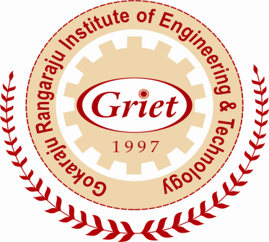

Internal Quality Assurance Cell (IQAC) and

Submission of Annual Quality Assurance Report (AQAR)

2013 - 14

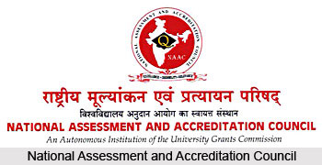
An Autonomous Institution of the University Grants Commission
P.O. Box. No. 1075, Opp: NLSIU, Nagarbhavi, Bangalore - 560 072 India

The Annual Quality Assurance Report (AQAR) of the IQAC

All NAAC accredited institutions will submit an annual self-reviewed progress report to NAAC, through its IQAC. The report is to detail the tangible results achieved in key areas, specifically identified by the institutional IQAC at the beginning of the academic year. The AQAR will detail the results of the perspective plan worked out by the IQAC. (Note: The AQAR period would be the Academic Year. For example, July 1, 2012 to June 30, 2013)

Part – A
1. Details of the Institution
Gokaraju Rangaraju Institute of Engineering and Technology (GRIET)
1.1 Name of the Institution
Bachupally
1.2 Address Line 1
Kukatpally
Address Line 2
Hyderabad
City/Town
Telangana
State
500090
Pin Code
info@griet.ac.in
Institution e-mail address
+91 40 65864440, 4441

G
Contact Nos.
Dr. Jandhyala N Murthy
Name of the
Head of the Institution:

+91 40 65864440
Tel. No. with STD Code:
+91 9391184994
Mobile:
Dr. D.Sailaja
Name of the IQAC Co-ordinator:
+91 9704137989
Mobile:
iqac@griet.ac.in
IQAC e-mail address:
APCOGN15432
1.3 NAAC Track ID
EC/64/A&A/28 dated 08-7-2013
1.4 NAAC Executive Committee
No. & Date:

www.griet.ac.in
1.5 Website address:
www.griet.ac.in \files\ AQAR13-14.doc
Web-link of the AQAR:
1.6 Accreditation Details
Sl. No. | Cycle | Grade | CGPA | Year of Accreditation | Validity Period
1 | 1st Cycle | A | 3.14 | 2013 | 5 years
2 | 2nd Cycle
3 | 3rd Cycle
4 | 4th Cycle

1/8/2013
1.7 Date of Establishment of IQAC : DD/MM/YYYY

2013-14
1.8 AQAR for the year (for example 2010-11)

1.9 Details of the previous year’s AQAR submitted to NAAC after the latest Assessment and Accreditation by NAAC ((for example AQAR 2010-11submitted to NAAC on 12-10-2011)
- AQAR _ AQAR2013-14 submitted to NAAC on 28/01/2016 (DD/MM/YYYY)
- AQAR__________________ ________________________ (DD/MM/YYYY)
- AQAR__________________ _______________________ (DD/MM/YYYY)
- AQAR__________________ _______________________ (DD/MM/YYYY)
1.10 Institutional Status
_

✓
University State Central Deemed Private
✓

Affiliated College Yes No
Constituent College Yes No

✓
Autonomous college of UGC Yes No
✓

✓

Regulatory Agency approved Institution Yes No
(eg. AICTE, BCI, MCI, PCI, NCI) AICTE
✓

Type of Institution Co-education Men Women

✓
Urban Rural Tribal

✓
✓
Financial Status Grant-in-aid UGC 2(f) UGC 12B

Grant-in-aid + Self Financing Totally Self-financing

✓

1.11 Type of Faculty/Programme

Arts Science Commerce Law PEI (Phys Edu)

TEI (Edu) Engineering Health Science Management

✓

✓
Others (Specify)

1.12 Name of the Affiliating University
Jawaharlal Nehru Technological University Hyderabad

1.13 Special status conferred by Central/ State Government-- UGC/CSIR/DST/DBT/ICMR etc
UGC
Autonomy by State/Central Govt. / University

University with Potential for Excellence UGC-CPE

DST Star Scheme UGC-CE

UGC-Special Assistance Programme DST-FIST

UGC-Innovative PG programmes Any other (Specify)

UGC-COP Programmes
2. IQAC Composition and Activities
1 9
2.1 No. of Teachers
2
2.2 No. of Administrative/Technical staff
7
2.3 No. of students
1
2.4 No. of Management representatives
2
2.5 No. of Alumni
2.6 No. of any other stakeholder and
2
Community representatives
1
2.7 No. of Employers/ Industrialists
1
2.8 No. of other External Experts
35
2.9 Total No. of members
2.10 No. of IQAC meetings held
4 6
1
1
2.11 No. of meetings with various stakeholders No. Faculty
2
1
1
Non-Teaching Staff Students Alumni Others
2.12 Has IQAC received any funding from UGC during the year? Yes No

✓
If yes, mention the amount

2.13 Seminars and Conferences (only quality related)
(i) No. of Seminars/Conferences/ Workshops/Symposia organized by the IQAC
14
3
4
11
6
Total Nos. International National State Institution Level
Engineering, Management, Skill development
(ii) Themes

2.14 Significant Activities and contributions made by IQAC
- Performance improvement of weak students by counselling and mentoring.
- Providing Career guidance and training for improving placements.
- Organising seminars, conferences, workshops for skill improvement.
- Conducting co and extracurricular activities for overall development of students.
- Organizing FDPs Encouraging Research activities and industry interactive programs.

2.15 Plan of Action by IQAC/Outcome
The plan of action chalked out by the IQAC in the beginning of the year towards quality
Enhancement and the outcome achieved by the end of the year *

Plan of Action | Achievements
Staff and students were motivated through meetings and various activities | Improved results, placements and admission into higher education .
* Attach the Academic Calendar of the year as Annexure.
2.16 Whether the AQAR was placed in statutory body Yes ✓ No

✓

Management Syndicate Any other body

Provide the details of the action taken
Action taken Report was ratified and IQAC started functioning

Part – B
Criterion – I
1. Curricular Aspects
1.1 Details about Academic Programmes
Level of the Programme | Number of existing Programmes | Number of programmes added during the year | Number of self-financing programmes | Number of value added / Career Oriented programmes
PhD
PG | 9 | 1
UG | 8
PG Diploma
Advanced Diploma
Diploma
Certificate
Others
Total | 17 | 1

Interdisciplinary
Innovative | MSME

1.2 (i) Flexibility of the Curriculum: CBCS/Core/Elective option / Open options
(ii) Pattern of programmes:
Pattern | Number of programmes
Semester | 17
Trimester
Annual

✓
✓
✓
✓
1.3 Feedback from stakeholders* Alumni Parents Employers Students
(On all aspects)
✓
✓

Mode of feedback : Online Manual Co-operating schools (for PEI)
*Please provide an analysis of the feedback in the Annexure

1.4 Whether there is any revision/update of regulation or syllabi, if yes, mention their salient aspects.
Yes, revision of curriculum is done for every 3 years

1.5 Any new Department/Centre introduced during the year. If yes, give details.
Yes, MSME (Micro Small Medium Enterprise Business Incubation Centre) Incubation centre is in process.

Criterion – II
2. Teaching, Learning and Evaluation
2.1 Total No. of permanent faculty
Total | Asst. Professors | Associate Professors | Professors | Others
307 | 217 | 56 | 34
36
2.2 No. of permanent faculty with Ph.D.
2.3 No. of Faculty Positions Recruited (R) and Vacant (V) during the year
Asst. Professors |  | Associate Professors |  | Professors |  | Others |  | Total
R | V | R | V | R | V | R | V | R | V
51 | - | 2 | - | 4 | - | - | - | 57 | -
2
0
0
2.4 No. of Guest and Visiting faculty and Temporary faculty

2.5 Faculty participation in conferences and symposia:

No. of Faculty | International level | National level | State level
Attended Seminars/ Workshops | 60 | 30 | 15
Presented papers | 52 | 25 | 5
Resource Persons | - | 6 | 10

2.6 Innovative processes adopted by the institution in Teaching and Learning:
More emphasis on practical skills, Remedial classes for weak students, Workshop for skill development, EDP competitions/Lectures for innovative skills, Guest lectures, Career guidance for placements

180 180
2.7 Total No. of actual teaching days
during this academic year
2.8 Examination/ Evaluation Reforms initiated by
Examination web portal to serve students.
Bar coding, Double evaluation on revaluation request from student.

the Institution (for example:
Open Book Examination, Bar Coding,
Double Valuation, Photocopy,
Online Multiple Choice Questions)

2.9 No. of faculty members involved in curriculum
5
45
4
Restructuring/revision/syllabus development
as member of Board of Study/Faculty
/Curriculum Development workshop
68 %
2.10 Average percentage of attendance of students

2.11 Course/Programme wise distribution of pass percentage :

Title of the Programme | Total no. of students appeared | Division
Title of the Programme | Total no. of students appeared | Distinction % | I % | II % | III % | Pass %
EEE | 143 | 98 | 22 | 1 | - | 85
Mech | 139 | 73 | 36 | 2 | - | 80
ECE | 147 | 87 | 26 | 1 | - | 78
CSE | 144 | 67 | 31 | - |  | 68
IT | 126 | 61 | 25 | 2 |  | 70
Civil | 141 | 68 | 34 | 6 |  | 77
BME | 33 | 19 | 7 |  |  | 79
BT | 35 | 21 | 7 |  |  | 80
2.12 How does IQAC Contribute/Monitor/Evaluate the Teaching & Learning process:
Principal and Director conduct periodical meetings with Heads of the Departments and Faculty and motivate them for effective teaching and learning activities, for improved results and placements. In addition to this various motivational programmes were conducted.
2.13 Initiatives undertaken towards faculty development
Faculty / Staff Development Programmes | Number of faculty  benefitted
Refresher courses | 6
UGC – Faculty Improvement Programme | -
HRD programmes | 3
Orientation programmes | 3
Faculty exchange programme | 5
Staff training conducted by the university | 4
Staff training conducted by other institutions | 5
Summer / Winter schools, Workshops, etc. | 4
Others | 12
2.14 Details of Administrative and Technical staff
Category | Number of Permanent  Employees | Number of Vacant  Positions | Number of permanent positions filled during the Year | Number of positions filled temporarily
Administrative Staff | 20 | Nil | 4 | Nil
Technical Staff | 78 | Nil | 12 | Nil
Criterion – III
3. Research, Consultancy and Extension
3.1 Initiatives of the IQAC in Sensitizing/Promoting Research Climate in the institution
Faculty are encouraged to write projects. They are encouraged to do innovative products and file patents. Staff are motivated to pursue their PhD’s

3.2 Details regarding major projects
 | Completed | Ongoing | Sanctioned | Submitted
Number | 3 | 4 | 2 | 18
Outlay in Rs. Lakhs | 29 | 61.1 | 19.9

3.3 Details regarding minor projects
 | Completed | Ongoing | Sanctioned | Submitted
Number | 0 | 7 | 7 | 5
Outlay in Rs. Lakhs |  | 17.65 | 17.653

3.4 Details on research publications
 | International | National | Others
Peer Review Journals | 54  35  04 | 10  03  -
Non-Peer Review Journals | 54  35  04 | 10  03  -
e-Journals | 54  35  04 | 10  03  -
Conference proceedings | 52 | 25

3.5 Details on Impact factor of publications:
0.2-5
3
20
15
Range Average h-index Nos. in SCOPUS

3.6 Research funds sanctioned and received from various funding agencies, industry and other organisations
Nature of the Project | Duration  Year | Name of the  funding Agency | Total grant  sanctioned | Received
Major projects | 3 | SERB | 14.0 lacs | 05.0 lacs
Minor Projects | 2 | UGC | 17.6 lacs | 13.9 lacs
Interdisciplinary Projects
Industry sponsored
Projects sponsored by the University/ College
Students research projects
(other than compulsory by the University)
Any other(Specify)
Total |  |  | 31.6 lacs | 18.9 lacs

3.7 No. of books published i) With ISBN No. Chapters in Edited Books
2

1
ii) Without ISBN No.
3.8 No. of University Departments receiving funds from
UGC-SAP CAS DST-FIST

DPE DBT Scheme/funds
3.9 For colleges Autonomy CPE DBT Star Scheme
✓

INSPIRE CE Any Other (specify)

3.10 Revenue generated through consultancy
2 Lakhs
Level | International | National | State | University | College
Number | 3 | 2 | - | - | 2
Sponsoring agencies | AICTE  TEQIP | AICTE |  |  | GRIET
3.11 No. of conferences
Organized by the Institution
20
3.12 No. of faculty served as experts, chairpersons or resource persons
2
6
10
3.13 No. of collaborations International National Any other
10
3.14 No. of linkages created during this year

3.15 Total budget for research for current year in lakhs:
59 Lakhs
5Lakhs
From funding agency From Management of University/College
Total
64 Lakhs

3.16 No. of patents received this year
Type of Patent |  | Number
National | Applied | -
National | Granted | -
International | Applied | -
International | Granted | -
Commercialised | Applied | 2
Commercialised | Granted | 1

3.17 No. of research awards/ recognitions received by faculty and research fellows
Of the institute in the year
Total | International | National | State | University | Dist | College
 |  | 1

3.18 No. of faculty from the Institution
15
who are Ph. D. Guides
and students registered under them
58

3.19 No. of Ph.D. awarded by faculty from the Institution
5

3.20 No. of Research scholars receiving the Fellowships (Newly enrolled + existing ones)
2
0
JRF SRF Project Fellows Any other
0
0

3.21 No. of students Participated in NSS events: 750

✓
University level State level
National level International level

3.22 No. of students participated in NCC events: -

University level State level
National level International level

3.23 No. of Awards won in NSS: 01
✓
University level State level

National level International level

3.24 No. of Awards won in NCC: ----
University level State level

National level International level

3.25 No. of Extension activities organized

10
University forum College forum

3
10
NCC NSS Any other Teqip
3.26 Major Activities during the year in the sphere of extension activities and Institutional Social Responsibility
Pragnya a co curricular forum involving paper and posters presentations, project /product displays.
Environmental conscious programs in Reudo, Blood donation camps in NSS Pulse a college Fest , Games and Sports and other various competitions Spirals( Literary activities )Spices (culinary skills) Xkernals ( soft ware contest) Guest lectures work shops and Industry visits etc.

Criterion – IV
4. Infrastructure and Learning Resources
4.1 Details of increase in infrastructure facilities:
Facilities | Existing | Newly created | Source of Fund | Total
Campus area | 44011 sqm | ---- | Society | 44011
Class rooms | 5994 sqm | 309 sqm | Society | 6303 sqm
Laboratories | 8743 sqm | 830 sqm | Society | 9573sqm
Seminar Halls | 1494 sqm | ------ | Society | 1494sqm
No. of important equipments purchased (≥ 1-0 lakh) during the current year. | 252 | ------ | Society | 252
Value of the equipment purchased during the year (Rs. in Lakhs) | 110.25 | ------ | Society | 110.25
Others
4.2 Computerization of administration and library
Yes. Administration, Library, examination centre are all computerised.

4.3 Library services:
 | Existing |  | Newly added |  | Total
 | No. | Value | No. | Value | No. | Value
Text Books | 98659 | 244.00 L | 2451 | 12.0 L | 101200 | 256 L
Reference Books | 11250 | 15.0 L | 250 | 1.2 L | 11500 | 16.2 L
e-Books
Journals | 300 | 13. 0 L
e-Journals | 670 | 12.00 L
Digital Database
CD & Video
Others (specify) | NPTEL | 50,000

4.4 Technology up gradation (overall)
 | Total Computers | Computer Labs | Internet | Browsing Centres | Computer Centres | Office | Depart-ments | Others
Existing | 1105 | 900 | 15Mbps | 45 | 5 | 30 | 117 | 8
Added | 300 | 280 | 12Mbps | - | - | 10 | 3 | 7
Total | 1405 | 1180 | 27Mbps | 45 | 5 | 40 | 120 | 15

4.5 Computer, Internet access, training to teachers and students and any other programme for technology
Upgradation (Networking, e-Governance etc.)
Various Certification courses like OCJP, OCA, CCNA are offered for students and staff

4.6 Amount spent on maintenance in lakhs:
8
i) ICT
435
ii) Campus Infrastructure and facilities
12.6
iii) Equipments
0.71
iv) Others

456.31
Total :

Criterion – V
5. Student Support and Progression
5.1 Contribution of IQAC in enhancing awareness about Student Support Services
Information about the Student support services like Route bus facility, ATM service, Medical facility, Gym, Indoor and outdoor games etc will be sent to the student community by SMS alert, Notices and through IQAC student members.

5.2 Efforts made by the institution for tracking the progression
- Regular Meetings
- Monitoring Mechanisms
- Result Analysis
- Career Guidance and Counselling system
- Observing Placement Record
- Feedback system

UG | PG | Ph. D. | Others
3950 | 704 | -
5.3 (a) Total Number of students

(b) No. of students outside the state
23
0
(c) No. of international students

No | %
3026 | 65
Men Women
No | %
1628 | 35
Last Year (2012-2013) |  |  |  |  |  | This Year (2013-2014)
General | SC | ST | OBC | Physically Challenged | Total | General | SC | ST | OBC | Physically Challenged | Total
1862 | 513 | 188 | 1559 | - | 4122 | 2061 | 549 | 205 | 1839 | - | 4654
Demand ratio Dropout % 1
5.4 Details of student support mechanism for coaching for competitive examinations (If any)
Communication skills improvement Programs to face competitive examinations, GATE coaching.

800
No. of students beneficiaries

5.5 No. of students qualified in these examinations

42

NET SET/SLET GATE CAT
IAS/IPS etc State PSC UPSC Others

10

5.6 Details of student counselling and career guidance
All the students, along with parents will meet career guidance cell in the beginning of the academic year for guidance. Those with less attendance and poor academic performance are monitored by career guidance cells and mentors of the group. In addition, Career Guidance Cell organizes various activities for improving Communication Skills, Personality Development Programmes and Campus Recruitment Training programmes periodically.

250
No. of students benefitted
5.7 Details of campus placement
On campus |  |  | Off Campus
Number of Organizations Visited | Number of Students Participated | Number of Students Placed | Number of Students Placed
38 | 930 | 330 | 50

5.8 Details of gender sensitization programmes
There is a woman development cell, it conducts meetings, motivational and sensitization programmes periodically.

5.9 Students Activities
5.9.1 No. of students participated in Sports, Games and other events 39
13
1

State/ University level National level International level
Inter Institutional
25
No. of students participated in cultural events

State/ University level National level International level
5.9.2 No. of medals /awards won by students in Sports, Games and other events

1
Sports : State/ University level National level International level

Cultural: State/ University level National level International level

5.10 Scholarships and Financial Support
 | Number of  students | Amount
Financial support from institution | 50 | 6 00000
Financial support from government | 2200 | 8,78,42 ,800
Financial support from other sources | 250 | 50 00000
Number of students who received International/ National recognitions

5.11 Student organised / initiatives
1

1
Fairs : State/ University level National level International level
1

Exhibition: State/ University level National level International level
2
5.12 No. of social initiatives undertaken by the students

5.13 Major grievances of students (if any) redressed: ______________________________________

Criterion – VI
6. Governance, Leadership and Management
6.1 State the Vision and Mission of the institution
Vision: To be among the best of the institutions for engineers and technologists with attitudes, skill and knowledge and to become an epicentre of creative solutions.
Mission: To achieve and impart quality education with an emphasis on practical skills and social relevance.

6.2 Does the Institution has a management Information System
Yes,
- GRIP (GRIET Information Portal)
- GSTATS (GRIET Student Statistics)
- TCS-iON (Campus Management Solution)

6.3 Quality improvement strategies adopted by the institution for each of the following:
6.3.1 Curriculum Development
Board of Studies meetings are conducted to monitor and modulate the curriculum to suit the industry and all stake holders needs

6.3.2 Teaching and Learning
- Qualified and experienced staff members are recruited and teaching aids like LCD, OHP are provided.
- Guest lectures by eminent personalities to enrich teaching and learning process.
- MOOC lectures by QEEE, IIT Bombay, Kharagpur

6.3.3 Examination and Evaluation
- There will be two internal exams and one final examination.
- Evaluation is by external examiners.
- Continuous and end- semester evaluations.
- Question paper setters for end examination are from outside the college.
- Evaluation involves coding and decoding of answer scripts to ensure unbiased evaluation

6.3.4 Research and Development
- There is an R&D promoting atmosphere by way of periodical meetings, lectures by eminent personalities.
- Access to internet and e-journals etc.
- Three International journals are published by GRIET.

6.3.5 Library, ICT and physical infrastructure / instrumentation
- Library and Information Center serves as resource centre with collection of books, journals, e-resources equipped with 30 systems having Wi-Fi. Library automated for issue/ receipt with bar coding.
- ICT Infrastructure involves LCD Projectors, Desktops, Printers, Internet, Power Generator and Softwares

6.3.6 Human Resource Management
Administration staff allocated for looking into HR details. It contains Attendance, Performance Appraisals etc.,

6.3.7 Faculty and Staff recruitment
- News advertisement, website notifications.
- Screening Resumes and Intimation to the selected candidates.
- Written Test for those candidates
- Interview by Department experts
- Demonstration and Interview by Management persons
- Ratification by University
- Student Faculty ratio is 15:1
- Cadre ratio is 1:2:6 (1 Professor, 2 Associate Professors, 6 Assistant Professors)
- Qualification, eligibility and pay scale as per the norms of AICTE, UGC

6.3.8 Industry Interaction / Collaboration
- Industry experts are invited for guest lectures, seminars, workshops and collaborative research.
- Students are encouraged to do their project with industry collaboration.
- GRIET is establishing Incubation Centres in collaboration with Industries.
- Encourages students for Internships and Industry Visits

6.3.9 Admission of Students
- The candidates who want to seek admission in GRIET have to qualify in the EAMCET ( Engineering ,Agricultural and Medical Common Entrance Test ) examination conducted by Govt. of Andhra Pradesh . To be eligible for appearing in the EAMCET examination, the student should have passed the 10 + 2 with Maths,Physics and Chemistry as their main stream. The candidates should attend the counselling for admission into the Engineering colleges conducted by the Convenor. Based on the rank obtained in EAMCET, candidates can opt for GRIET as per the availability of the college and branch at the time of counselling. 70% through convenor quota through state administered counselling
- The 30% of NRI Quota is based on merit.
- The Convener of ECET admits 10% of the candidates from the stream of Diploma holders.
- PG Students joins based on PGCET, GATE and ICET’s

Teaching | Provisions for PF, Faculty club, and free transportation facility
Non teaching | E-learning programmes, free food and medical facility, initiatives for good performance and free transportation
Students | Scholarships, medical facility, free food scheme for  Economically backward students. Initiative for good performance in academics and beyond academics.

6.4 Welfare schemes for

6.5 Total corpus fund generated
20.35 lakhs
✓

6.6 Whether annual financial audit has been done Yes No

6.7 Whether Academic and Administrative Audit (AAA) has been done?
Audit Type | External |  | Internal
Audit Type | Yes/No | Agency | Yes/No | Authority
Academic | ✓ | Audit by NPIU | ✓ | Principal
Administrative | ✓ | Audit by NPIU | ✓ | Principal

6.8 Does the University/ Autonomous College declares results within 30 days?
✓

For UG Programmes Yes No
✓

For PG Programmes Yes No
6.9 What efforts are made by the University/ Autonomous College for Examination Reforms?
- Separate examination portal, which supports timely management of exam schedules, results and other related issues.
- End examination question paper setters are from other colleges and Universities
- Coding and decoding of answer scripts in evaluation process
- Evaluation of answer scripts by the Professors of other colleges and Universities
- Recounting and Revaluation facility to student

6.10 What efforts are made by the University to promote autonomy in the affiliated/constituent colleges?
JNTUH sanctioned autonomous status for the institutions which maintain quality. GRIET received autonomous status from 2011-12 which is conferred by UGC for 5 years from 2014 - 15

6.11 Activities and support from the Alumni Association
Alumni association meets once in a year, provides guidance regarding career development.

6.12 Activities and support from the Parent – Teacher Association
- Daily SMS alert to parents about their ward’s attendance.
- Counselling is provided for both parents and students by constant monitoring through career guidance cell and class mentors.

6.13 Development programmes for support staff
- Computer training and technical skill improvement programs are conducted for supporting staff at regular intervals.
- Free food facility in the college campus through Annapurna Pathakam initiated by the Institute.
- Free medical facility within the campus

6.14 Initiatives taken by the institution to make the campus eco-friendly
- Plastic free zone campus initiatives
- Waste recycling and Rain water harvesting modalities
- Environment awareness programs and plantation programs conducted by NSS wing of GRIET
- Replacement of CR is with LED monitors, Introduction of LED lights, and
- Installation of 110 KW solar plant.

Criterion – VII
7. Innovations and Best Practices
7.1 Innovations introduced during this academic year which have created a positive impact on the
functioning of the institution. Give details.
- Career guidance to mentor and monitor for academic excellence.
- Practical skill improvement by increasing practical sessions i.e., 3 sessions instead of 2 per week.
- Organizing industry oriented work shops

7.2 Provide the Action Taken Report (ATR) based on the plan of action decided upon at the
beginning of the year

Attendance of the students has improved. Students gained good laboratory practices.
Placements and higher studies improved. Industry interaction intensified.

7.3 Give two Best Practices of the institution (please see the format in the NAAC Self-study Manuals)
Emphasis for more practical orientation. In house projects increased, Innovative ideas leading to product development are encouraged. Road shows are organised to display projects Emphasis on Industry collaborations.

*Provide the details in annexure (annexure need to be numbered as i, ii,iii)
7.4 Contribution to environmental awareness / protection
College organizes a special environmental concerned programme called “Reudo” which focuses on multiple events connected with environmental protection

7.5 Whether environmental audit was conducted? Yes No

✓

7.6 Any other relevant information the institution wishes to add. (for example SWOT Analysis)
Strengths
Qualified, experienced, dedicated staff Well structured curriculum Excellent infra structure facilities Well-equipped laboratories Enriched and automated library career counselling and Placement cell Active Mentoring system Personality Development and communication improvement Programme for all the students Skill Improvement workshops Industry oriented projects Co and Extracurricular activities for overall development
Weaknesses
English communication gap with students from rural back ground Deficiency of trained non-teaching staff [Class III & IV] Challenges regarding training the new faculty due to frequent mobility personnel every year.
Opportunities: To introduce new courses with societal and Industry needs Higher education opportunities in India and Abroad Approach to Industry awareness Technical skill Improvements Industrial consultancy.
Challenges: Motivating students to give more time to develop English language skills. Maintenance of laboratory equipment, Lack of skilled lab faculty, less interest towards some courses, Limited technical expertise, Minimal Industry support.

8. Plans of institution for next year
- Efforts for skill development and innovative thinking
- Industry collaborated projects and research will be focussed.
- Student support like career guidance will be enhanced.

Dr. D.Sailaja Dr. Jandhyala N Murthy
Coordinator, IQAC Cell Principal & Chairman IQAC Cell
Gokaraju Rangaraju Institute of Gokaraju Rangaraju Institute of
Engineering and Technology (Autonomous) Engineering and Technology (Autonomous)
Bachupally, Kukatpally, Hyderabad, Bachupally, Kukatpally, Hyderabad
Telangana, India - 500090 Telangana , India- 500090
Signature of the Coordinator, IQAC Signature of the Chairperson, IQAC

_______***_______

Annexure I
Abbreviations:
AICTE All India Council for Technical Education
CAS - Career Advanced Scheme
CAT - Common Admission Test
CBCS - Choice Based Credit Syste
GATE - Graduate Aptitude Test
NET - National Eligibility Test
SAP - Special Assistance Programme
SLET - State Level Eligibility Test
UPE - University with Potential Excellence
UPSC - Union Public Service Commission
GRIET - Gokaraju Rangaraju Institute Engineering and Technology
TEQIP - Technical Education Quality Improvement Program
MSME - Micro Small Medium Enterprises
OCJP - Oracle Certified Java Professional
OCA - Oracle Certified Asssociate
CCNA - Cisco Certified Network Associate
QEEE- Quality Enhancement in Engineering Education
MOOC- Massive Open Online Course
PGCET- Post Graduate Common Entrance Test
ICET- Integrated Common Entrance Test
NPIU- National Project Implementation Unit

Annexure - II
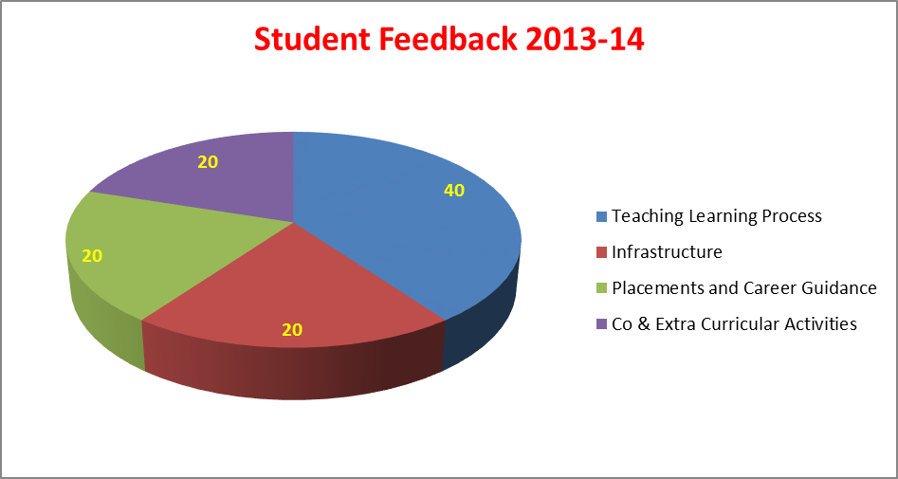

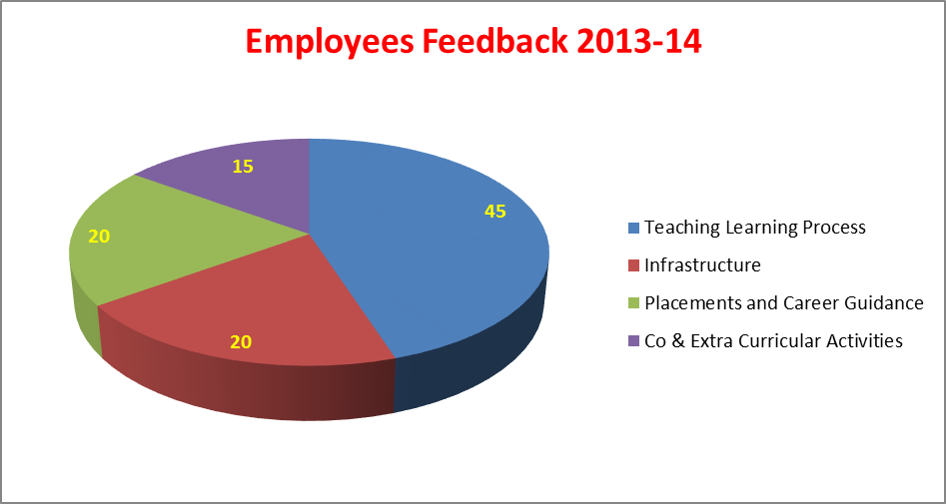

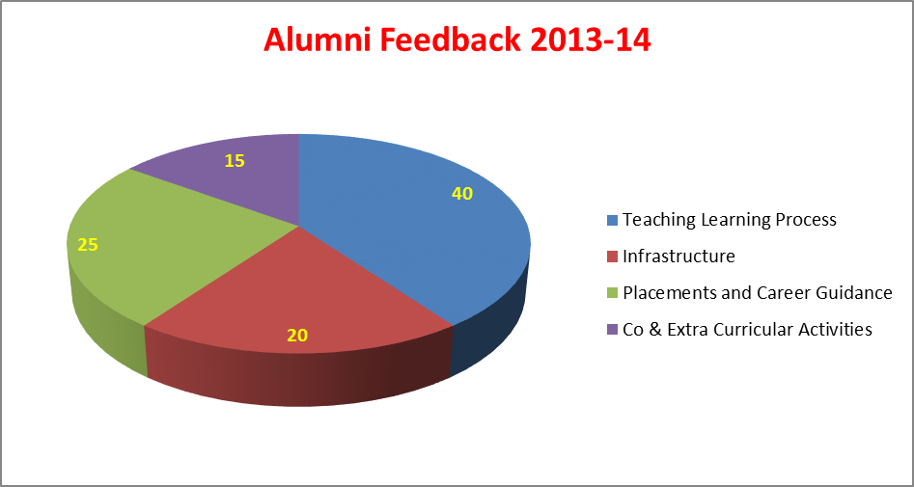

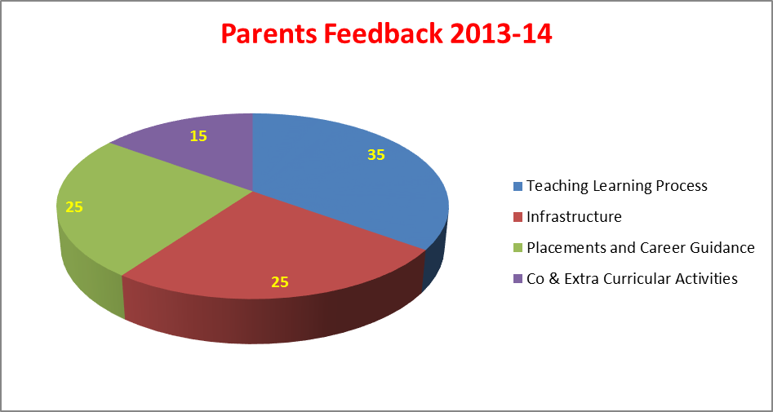
Annexure - III

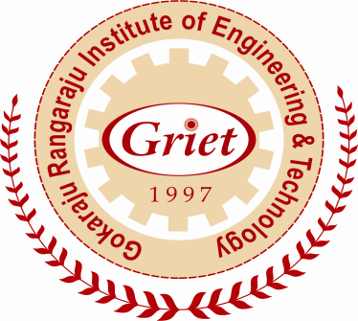

Calendar 2013 - 14

Gokaraju Rangaraju Institute of Engineering and Technology
(Autonomous under JNTUH)
Bachupally, Kukatpally, Hyderabad – 500 090

National Anthem

Jana Gana Mana Adhinayak Jai Hey
Bharat Bhagya Vidhata
Punjab Sindh Gujarat Maratha
Dravid Utkal Banga
Vindhya Himachal Yamuna Ganga
Uchchal Jaladhi Taranga
Tab Shubha Name Jage
Tab Shubh Ashish Mange
Gaye Tab Jaya Gatha
Jana Gana Mangal Dayak Jaya Hey
Bharat Bhagya Vidhata
Jaya Hey, Jaya Hey, Jaya Hey
Jaya, Jaya, Jaya, Jaya Hey

About us
GRIET is one of the premier engineering colleges, imparting quality technical education to the students, drawn from competitive examinations, conducted by the Government of Andhra Pradesh. The Institute is located in a sprawling campus with buildings, architectural masterpieces, built on a hillock, on Nizampet Road, just 4 km from JNTUH, Kukatpally, Hyderabad.
The Institute was established in the year 1997 by Dr. G. Gangaraju in fond memory of his father, Late Sri Gokaraju Rangaraju, a crusader in the field of education. Dr. G Gangaraju is the Chairman, Laila Group of Industries, with multi-faceted interests in Pharmaceuticals, Paper, Software, Agro Industries and Exports.

Attendance & Promotion Rules
GRIET follows the Attendance & Promotion rules laid down by JNTU, as summarized below: Shortage of attendance in aggregate up to 10% (65% and above and below 75%) in each semester or 1 year to be condoned by the Vice-Chancellor on the recommendations of the Sub-Committee of the Academic Senate on valid and genuine grounds.
A student shall be promoted from one class to the next only if he/she fulfills the academic requirements of credits from regular and supplementary examinations, as laid down by Academic Regulations applicable for that batch of admission.

GRIET Code of Conduct
All the students of GRIET should abide by the provisions of the following Code of Conduct.
- The student of GRIET should display exemplary conduct and character, not only within the Campus but also outside.
- The student should be regular to the classes and should conduct with dignity and decorum, befitting to a professional.
- The student should be conscious of cleanliness and hygiene.
- The student should respect teaching and non-teaching staff.
- The student should feel a sense of belonging and accordingly protect the furniture, class room & laboratory equipment and library books.
- The student of GRIET should not disturb the peace, serenity and academic life of the Campus.
- The College premises and buildings should be kept clean. Writing of any nature and sticking of posters and notices on the buildings or walls are strictly prohibited.
- Any student(s) responsible for bringing outside elements into the Campus for creating law and order problems will be severely dealt with.
- Eve-teasing on the Campus is severely punishable.
- Ragging in any form to any extent is strictly prohibited.

Violation of any of the above guidelines will invite
fine, suspension or dismissal.

Coordinators
B. Tech (CCC) | Mr. C. Srikanth, Asst. Prof. (BT)
College Diary | Ms. K. L. Sushma, Asst. Prof. (IT)
CPM (JKC) | Mr. N. V. Ganapathi Raju,  Assoc. Prof (MCA)
TEQIP | Dr. K. G. K. Murti, Prof. (Mech)
FDP | Mrs. T. Padma, Assoc. Prof. (BME)
EDP Cell | Dr. PAPN. Varma, Assoc. Prof. (ME)
Faculty Club | Ms. D. Ramya , Asst. Prof. (EEE)
Free Software Movement | Dr. Y. Vijaya Lata, Prof (CSE)
GCAP | Ms. K. Prasanna Lakshmi,  Assoc. Prof. (IT)
Alumni Association | Mr. K. Koteswara Rao,  Assoc. Prof. (Mech)
Gaming Club | Student President
Robotic Club | Student President
Technology Cell | Mr. PPC Prasad,  Assoc. Prof. (Mech)
Web Page | Mr. Y. J. Nagendra Kumar,  Assoc.Prof. (IT)
Women Development Cell | Ms. V. N. Rama Devi, Asst. Prof. (BS)
II B. Tech | Dr. Adapa Rama Rao,  Prof. (Mech)
M. Tech | Mr. K. Jamal, Asst.  Prof (ECE)

Co-curricular & Extra Curricular Activities In charges
No | Activity | In charge Department
1 | Rhythms | Civil Engineering
2 | Spices | MCA
3 | Spirals | MBA
4 | Reflections | MBA
5 | Quizzicals | Bio-Medical Engineering
6 | Pragnya | College Committee
7 | Pulse | College Committee
8 | Annual Day | Computer Science Engineering
9 | Souvenir | Electronics & Communication Engineering
10 | Xkernel | Information Technology
11 | Scientific Forestep | Electrical & Electronics Engineering
12 | NSS | Mechanical Engineering
13 | Sports & Games | Physical Department
14 | Graduation Day | I Year Vice Principal

Committees and Professional Bodies
No | Committee | Chairman
1 | Discipline Committee | Dr. N. Sunil Kumar,  Assoc. Prof. (BT)
2 | Editorial Committee | Dr. P. B. Appa Rao,  Prof. (MBA)
3 | Library Committee | Mr. M. Kiran,  Assoc. Prof. (ECE)
4 | Canteen Committee | Ms. V. Padma,  Asst. Prof(IT)
5 | Transport Committee | Mr. P. Santhi Babu,  Assoc. Prof. (MECH)
6 | Time Table Committee | Ms. J. Sridevi,  Assoc. Prof. (EEE)
7 | Public Relations | Sri. P. Gopal Krishna,  Assoc.Prof. (IT)
8 | e-Resources Committee | Dr. Althaf Hussain Basha,  Prof. (MCA)

No | Professional Bodies | In charge Department
1 | CSI | IT
2 | IEEE | CSE
3 | ISTE | BT
4 | SAE | ME
5 | IETE | ECE

Revised Academic Calendar: Academic year 2013-14
I - B. Tech. – First Semester
S. No | Event | Period | Duration
1 | Orientation Program | 23-09-2013 | 1 day
2 | 1st Spell of Instruction | 23-09-2013 to 16-11-2013 | 8 weeks
3 | 1st Mid-term Examination | 18-11-2013 to 20-11-2013 | 3 days
4 | 2nd Spell of Instruction | 21-11-2013 to 08-01-2014 | 7 weeks
5 | 2nd Mid-term Examination | 09-01-2014 to 11-01-2014 | 3 days
6 | Preparation | 13-01-2014 to 18-01-2014 | 1 week
7 | End Semester& Practical Examinations | 20-01-2014 to 08-02-2014 | 3 weeks
8 | Commencement of Second Semester | 10-02-2014 | -------------
I - B. Tech. – Second Semester
S. No | Event | Period | Duration
1 | 1st Spell of Instruction | 10-02-2014 to 29-03-2014 | 7 weeks
2 | 1st Mid-term Examination | 31-03-2014 to 02-04-2014 | 3 days
3 | 2nd Spell of Instruction | 03-04-2014 to 28-05-2014 | 8 weeks
4 | 2nd Mid-term Examination | 29-05-2014 to 31-05-2014 | 3 days
5 | Preparation | 02-06-2014 to 07-06-2014 | 1 week
7 | End Semester& Practical Examinations | 09-06-2014 to 28-06-2014 | 3 weeks
8 | Summer Vacation | 30-06-2014 to 05-07-2014 | 1 week
9 | Commencement of First Semester, A.Y.2014-2015 | 07-07-2014 | ------------

II & III - B. Tech. – First Semester
S. No | Event | Period | Duration
1 | 1st Spell of Instruction | 01-07-2013 to 17-08-2013 | 7 weeks
2 | 1st Mid-term Examination | 19-08-2013 to 21-08-2013 | 3 days
3 | 2nd Spell of Instruction | 22-08-2013 to 09-10-2013 | 7 weeks
4 | 2nd Mid-term Examination | 10-10-2013 to 12-10-2013 | 3 days
5 | 3rd Spell of Instruction | 14-10-2013 to 02-11-2013 | 3 weeks
6 | Preparation | 04-11-2013 to 09-11-2013 | 1 week
7 | End Semester Examinations | 11-11-2013 to 23-11-2013 | 2 weeks
8 | Supplementary & Practical Examinations | 25-11-2013 to 07-12-2013 | 2 weeks
8 | Semester Break | 09-12-2013 to 14-12-2013 | 1 week
9 | Commencement of Second Semester | 16-12-2013 | ---------

II & III - B. Tech – Second Semester
S. No | Event | Period | Duration
1 | 1st Spell of Instruction | 16-12-2013 to 01-02-2014 | 7 weeks
2 | 1st Mid-term Examination | 03-02-2014 to 05-02-2014 | 3 days
3 | 2nd Spell of Instructions | 06-02-2014 to 26-03-2014 | 7 weeks
4 | 2nd Mid-term Examination | 27-03-2014 to 29-03-2014 | 3 days
5 | 3rd Spell of Instructions | 31-03-2014 to 19-04-2014 | 3 weeks
6 | Preparation | 21-04-2014 to 26-04-2014 | 1 week
7 | End Semester Examinations | 28-04-2014 to 17-05-2014 | 3 weeks
8 | Supplementary& Practical Examinations | 19-05-2014 to 07-06-2014 | 3 weeks
9 | Summer Vacation | 09-06-2014 to 05-07-2014 | 4 weeks
10 | Commencement of First Semester, A.Y.2014-2015 | 07-07-2014 | -----------

IV - B. Tech. – First Semester

S. No | Event | Period | Duration
1 | 1st Spell of Instruction | 01.07.2013 to 24.08.2013 | 8 Weeks
2 | 1st Mid-term examination | 26.08.2013 to 28.08.2013 | 3 Days
3 | 2nd Spell of Instruction | 29.08.2013 to 11.10.2013 | 6^{1/2} Weeks
4 | Continuation of 2nd Spell | 21-10-2013 to 26-10-2013 | 1 Week
4 | 2nd Mid-term examination | 28-10-2013 to 30-10-2013 | 3 Days
5 | Practical Examinations & Preparation | 31-10-2013 to 08-11-2013 | 9 Days
6 | End semester examinations | 11.11.2013 to 23.11.2013 | 2 Weeks
7 | Supplementary Examinations | 25.11.2013 to 7.12.2013 | 2 Weeks
8 | Commencement of class work for II semester for the A. Y. 2013-14 | 9.12.2013

IV - B. Tech. – Second Semester

S. No | Event | Period | Duration
1 | 1st Spell of Instruction | 9.12.2013 to 10.1.2014 | 5 Weeks
2 | Continuation of 1st Spell | 20.1.2014 to 07.02.2014 | 3 Weeks
2 | 1st Mid-term examination | 10.02.2014 to 12.02.2014 | 3 Days
3 | 2nd Spell of Instruction | 13.02.2014 to 05.04.2014 | 7^{1/2} Weeks
4 | 2nd Mid-term examination | 07.04.2014 to 09.04.2014 | 3 Days
5 | Practical Examinations& Preparation | 10.04.2014 to 19.04.2014 | 9 Days
6 | End semester examinations | 21.04.2014 to 03.05.2014 | 2 Weeks
7 | Supplementary Examinations | 05.05.2014 to 17.05.2013 | 2 Weeks
8 | Commencement of class work for II semester for the A. Y. 2014-15 | 16.06.2014

M. Tech. (2013-14) First Year – First Semester

S. No | Event | Period | Duration
1 | I Unit of Instructions | 02.12.2013 to 01.02.2014 | 9 Weeks
2 | I Mid Examinations | 03.02.2014 to 08.02.2014 | 1 Week
3 | II Unit of Instructions | 10.02.2014 to 05.04.2014 | 8 Weeks
4 | II Mid Examinations | 07.04.2014 to 12.04.2014 | 1 Week
5 | Preparation and Practical Examinations | 14.04.2014 to 19.04.2014 | 1 Week
6 | End Semester Examinations | 21.04.2014 to 03.05.2014 | 2 Weeks
7 | Summer Vacation | 05.05.2014 to 31.05.2014 | 4 Weeks
8 | Commencement of Class Work for Second Semester | 02.06.2014 | -----------

M. Tech. (2013-14) First year – Second Semester

S. No | Event | Period | Duration
1 | I Unit of Instructions | 02.06.2014 to 02.08.2014 | 9 weeks
2 | 1st Mid-term Examination | 04.08.2014 to 09.08.2014 | 1 Week
3 | II Unit of Instructions | 11.08.2014 to 04.10.2014 | 8 Weeks
4 | 2nd Mid-term Examination | 06.10.2014 to 11.10.2014 | 1 Week
5 | Practical Examinations & Preparation | 13.10.2014 to 18.10.2014 | 1 Week
6 | End Semester Examinations | 20.10.2014 to 01.11.2014 | 2 Weeks

M. Tech. (2013-14) Second year – First Semester
S. No | Event | Period | Duration
1 | Spell of Instructions | 03.11.2014 to 04.04.2015 | 22 Weeks
2 | Seminar/ Comprehensive Viva Dates | 03.02.2015 and 05.02.2015 | 3 Days

MCA / MBA – First Semester
S. No | Event | Period | Duration
1 | 1st Spell of Instruction | 07.10.2013 to 30.11.2013 | 8 Weeks
2 | 1st Mid-term Examination | 02.12.2013 to 07.12.2013 | 1 Week
3 | 2nd Spell of Instruction | 09.12.2013 to 01.02.2014 | 8 Weeks
4 | 2nd Mid-term Examination | 03.02.2014 to 08.02.2014 | 1 Week
5 | Practical Examinations & Preparation | 10.02.2014 to 15.02.2014 | 1 Week
6 | End Semester Examinations | 17.02.2014 to 01.03.2014 | 2 Weeks
7 | Commencement of 2nd Semester | 10.03.2014 | ----------

MCA / MBA – Second Semester
S. No | Event | Period | Duration
1 | 1st Spell of Instruction | 10.03.2014 to 03.05.2014 | 8 Weeks
2 | 1st Mid-term Examination | 05.05.2014 to 10.05.2014 | 1 Week
2 | Summer Vacation | 12.05.2014 to 14.06.2014 | 5 Weeks
3 | 2nd Spell of Instructions | 16.06.2014 to 09.08.2014 | 8 Weeks
4 | 2nd Mid-term Examination | 11.08.2014 to 16.08.2014 | 1 Week
7 | Practical Examinations & Preparation | 18.08.2014 to 23.08.2014 | 1 Week
8 | End Semester Examinations | 25.08.2014 to 06.09.2014 | 2 Weeks
9 | Commencement of 3rd Semester | 15.09.2014 | ----------

MCA / MBA – Third Semester
S. No | Event | Period | Duration
1 | 1st Spell of Instruction | 05.08.2013 28.09.2013 | 8 Weeks
2 | 1st Mid-term Examination | 30.09.2013 05.10.2013 | 1 Week
3 | 2nd Spell of Instruction | 07.10.2013 30.11.2013 | 8 Weeks
4 | 2nd Mid-term Examination | 02.12.2013 07.12.2013 | 1 Week
5 | Practical Examinations & Preparation | 09.12.2013 14.12.2013 | 1 Week
6 | End Semester Examinations | 16.12.2013 28.12.2013 | 2 Weeks
7 | Commencement of 4thSemester | 06.01.2014 | -----------

* June-2013*
1-Jun-13 | Sat | First Saturday
3-Jun-13 | Mon | Academic Council meeting with Principal Mentor's Meeting
4-Jun-13 | Tue | Class Coordinator’s Meeting for attendance/marks
5-Jun-13 | Wed | HOD’s Meeting
6-Jun-13 | Thu | Departmental Staff Meeting by HOD
7-Jun-13 | Fri
8-Jun-13 | Sat
10-Jun-13 | Mon
11-Jun-13 | Tue
12-Jun-13 | Wed
13-Jun-13 | Thu
14-Jun-13 | Fri
15-Jun-13 | Sat
17-Jun-13 | Mon
18-Jun-13 | Tue
19-Jun-13 | Wed
20-Jun-13 | Thu
21-Jun-13 | Fri
22-Jun-13 | Sat
24-Jun-13 | Mon | CSE/IT/MCA Guest Lecture
25-Jun-13 | Tue | BT Guest Lecture, BME Guest Lecture, BS Guest Lecture
26-Jun-13 | Wed | MECH Guest Lecture
27-Jun-13 | Thu | EEE Guest Lecture, ECE Guest Lecture
28-Jun-13 | Fri
29-Jun-13 | Sat
* July-2013*
1-Jul-13 | Mon | Institute Development Meeting with Principal Mentor's Meeting
2-Jul-13 | Tue
3-Jul-13 | Wed | HOD’s Meeting
4-Jul-13 | Thu | Departmental Staff Meeting by HOD
5-Jul-13 | Fri | Co-Ordinators Meeting with Principal
6-Jul-13 | Sat | First Saturday
8-Jul-13 | Mon
9-Jul-13 | Tue
10-Jul-13 | Wed
11-Jul-13 | Thu
12-Jul-13 | Fri
13-Jul-13 | Sat | Graduation Day
15-Jul-13 | Mon | Parent's Meeting
16-Jul-13 | Tue
17-Jul-13 | Wed
18-Jul-13 | Thu
19-Jul-13 | Fri
20-Jul-13 | Sat
22-Jul-13 | Mon
23-Jul-13 | Tue
24-Jul-13 | Wed
25-Jul-13 | Thu
26-Jul-13 | Fri | CIVIL Guest Lecture
27-Jul-13 | Sat | EEE Guest Lecture, ECE Guest Lecture
29-Jul-13 | Mon | CSE/IT/MCA Guest Lecture
30-Jul-13 | Tue | BT Guest Lecture, BME Guest Lecture, BS Guest Lecture
31-Jul-13 | Wed | MECH Guest Lecture
* August-2013*
1-Aug-13 | Thu | Departmental Staff Meeting by HOD
2-Aug-13 | Fri | ICACM – 13
3-Aug-13 | Sat | ICACM - 13  First Saturday
5-Aug-13 | Mon | Mentor's Meeting
6-Aug-13 | Tue | Class Coordinator’s Meeting for attendance/marks
7-Aug-13 | Wed | HOD’s Meeting
8-Aug-13 | Thu
9-Aug-13 | Fri
10-Aug-13 | Sat | TEQIP-II Minutes of Meeting
12-Aug-13 | Mon | Seminar/FDP/Workshop for Teaching Faculty
13-Aug-13 | Tue
14-Aug-13 | Wed | Activity by Student Chapter
15-Aug-13 | Thu | Independence Day
16-Aug-13 | Fri
17-Aug-13 | Sat
19-Aug-13 | Mon
20-Aug-13 | Tue
21-Aug-13 | Wed
22-Aug-13 | Thu
23-Aug-13 | Fri | CIVIL Faculty Development Program
24-Aug-13 | Sat | CIVIL Faculty Development Program
26-Aug-13 | Mon | CSE/IT/MCA Guest Lecture
27-Aug-13 | Tue | CIVIL Guest Lecture, BT Guest Lecture, BME Guest Lecture, BS Guest Lecture
28-Aug-13 | Wed | Krishna Janmastami
29-Aug-13 | Thu | EEE Guest Lecture, ECE Guest Lecture
30-Aug-13 | Fri | MECH Guest Lecture
31-Aug-13 | Sat
* September-2013*
2-Sep-13 | Mon | Academic Council meeting with Principal Mentor's Meeting
3-Sep-13 | Tue
4-Sep-13 | Wed | HOD’s Meeting
5-Sep-13 | Thu | Departmental Staff Meeting by HOD
6-Sep-13 | Fri | Co-Ordinators Meeting with Principal
7-Sep-13 | Sat | First Saturday
9-Sep-13 | Mon | Ganesh Chaturthi
10-Sep-13 | Tue
11-Sep-13 | Wed
12-Sep-13 | Thu
13-Sep-13 | Fri
14-Sep-13 | Sat | Parent's Meeting
16-Sep-13 | Mon
17-Sep-13 | Tue
18-Sep-13 | Wed
19-Sep-13 | Thu
20-Sep-13 | Fri | CIVIL Guest Lecture
21-Sep-13 | Sat
23-Sep-13 | Mon | CSE/IT/MCA Guest Lecture
24-Sep-13 | Tue | BT Guest Lecture, BME Guest Lecture, BS Guest Lecture
25-Sep-13 | Wed | MECH Guest Lecture
26-Sep-13 | Thu | EEE Guest Lecture, ECE Guest Lecture  CIVIL Workshop
27-Sep-13 | Fri | CIVIL Workshop
28-Sep-13 | Sat
30-Sep-13 | Mon
* October-2013*
1-Oct-13 | Tue
2-Oct-13 | Wed | Gandhi Jayanthi
3-Oct-13 | Thu | Departmental Staff Meeting by HOD
4-Oct-13 | Fri | CIVIL Guest Lecture  Pragnya
5-Oct-13 | Sat | Pragnya
7-Oct-13 | Mon | Mentor's Meeting
8-Oct-13 | Tue | Class Coordinator’s Meeting for attendance/marks
9-Oct-13 | Wed | HOD’s Meeting
10-Oct-13 | Thu
11-Oct-13 | Fri
12-Oct-13 | Sat
14-Oct-13 | Mon | Dussehra
15-Oct-13 | Tue | Activity by Student Chapter
16-Oct-13 | Wed | Bakri Id
17-Oct-13 | Thu | CIVIL Faculty Development Program
18-Oct-13 | Fri | CIVIL Faculty Development Program
19-Oct-13 | Sat | Spices (Students)
21-Oct-13 | Mon | Seminar/FDP/Workshop for Non-Teaching Faculty
22-Oct-13 | Tue
23-Oct-13 | Wed
24-Oct-13 | Thu
25-Oct-13 | Fri
26-Oct-13 | Sat
28-Oct-13 | Mon | CSE/IT/MCA Guest Lecture
29-Oct-13 | Tue | BT Guest Lecture, BME Guest Lecture, BS Guest Lecture
30-Oct-13 | Wed | MECH Guest Lecture
31-Oct-13 | Thu | EEE Guest Lecture, ECE Guest Lecture
* November-2013*
1-Nov-13 | Fri
2-Nov-13 | Sat | First Saturday
4-Nov-13 | Mon | Institute Development Meeting with Principal Mentor's Meeting
5-Nov-13 | Tue
6-Nov-13 | Wed | HOD’s Meeting
7-Nov-13 | Thu | Departmental Staff Meeting by HOD
8-Nov-13 | Fri | Co-Ordinators Meeting with Principal
9-Nov-13 | Sat
11-Nov-13 | Mon
12-Nov-13 | Tue
13-Nov-13 | Wed
14-Nov-13 | Thu
15-Nov-13 | Fri
16-Nov-13 | Sat
18-Nov-13 | Mon
19-Nov-13 | Tue
20-Nov-13 | Wed
21-Nov-13 | Thu
22-Nov-13 | Fri
23-Nov-13 | Sat
25-Nov-13 | Mon | CSE/IT/MCA Guest Lecture  CIVIL Workshop
26-Nov-13 | Tue | BT Guest Lecture, BME Guest Lecture, BS Guest Lecture  CIVIL Workshop
27-Nov-13 | Wed | MECH Guest Lecture
28-Nov-13 | Thu | EEE Guest Lecture, ECE Guest Lecture
29-Nov-13 | Fri
30-Nov-13 | Sat
* December-2013*
2-Dec-13 | Mon | Academic Council meeting with Principal Mentor's Meeting  CIVIL National Seminar
3-Dec-13 | Tue | Class Coordinator’s Meeting for attendance/marks  CIVIL National Seminar
4-Dec-13 | Wed | HOD’s Meeting
5-Dec-13 | Thu | Departmental Staff Meeting by HOD
6-Dec-13 | Fri
7-Dec-13 | Sat | Scientific Forestep  First Saturday
9-Dec-13 | Mon
10-Dec-13 | Tue
11-Dec-13 | Wed
12-Dec-13 | Thu
13-Dec-13 | Fri
14-Dec-13 | Sat | Parent's Meeting
16-Dec-13 | Mon
17-Dec-13 | Tue
18-Dec-13 | Wed | Activity by Student Chapter
19-Dec-13 | Thu | CIVIL National Seminar
20-Dec-13 | Fri | CIVIL National Seminar
21-Dec-13 | Sat
23-Dec-13 | Mon | CSE/IT/MCA Guest Lecture
24-Dec-13 | Tue | BT Guest Lecture, BME Guest Lecture, BS Guest Lecture
25-Dec-13 | Wed | Christmas
26-Dec-13 | Thu | MECH Guest Lecture
27-Dec-13 | Fri | EEE Guest Lecture, ECE Guest Lecture
28-Dec-13 | Sat
30-Dec-13 | Mon
31-Dec-13 | Tue | Spices (Faculty)
* January-2014*
1-Jan-14 | Wed | HOD’s Meeting
2-Jan-14 | Thu | Departmental Staff Meeting by HOD
3-Jan-14 | Fri | Co-Ordinators Meeting with Principal
4-Jan-14 | Sat | First Saturday
6-Jan-14 | Mon | Institute Development Meeting with Principal Mentor's Meeting
7-Jan-14 | Tue
8-Jan-14 | Wed
9-Jan-14 | Thu | CIVIL Guest Lecture
10-Jan-14 | Fri | Seminar/FDP/Workshop for Teaching Faculty
11-Jan-14 | Sat | Quizzicals
13-Jan-14 | Mon | Ed-E-Milad
14-Jan-14 | Tue | Sankranthi
15-Jan-14 | Wed
16-Jan-14 | Thu
17-Jan-14 | Fri
18-Jan-14 | Sat | Pulse
20-Jan-14 | Mon
21-Jan-14 | Tue
22-Jan-14 | Wed
23-Jan-14 | Thu
24-Jan-14 | Fri
25-Jan-14 | Sat | Annual Day
27-Jan-14 | Mon | CSE/IT/MCA Guest Lecture  CIVIL Workshop
28-Jan-14 | Tue | BT Guest Lecture, BME Guest Lecture ,BS Guest Lecture  CIVIL Workshop
29-Jan-14 | Wed | MECH Guest Lecture
30-Jan-14 | Thu | EEE Guest Lecture, ECE Guest Lecture
31-Jan-14 | Fri
* February-2014*
1-Feb-14 | Sat | First Saturday
3-Feb-14 | Mon | Mentor's Meeting
4-Feb-14 | Tue | Class Coordinator’s Meeting for attendance/marks
5-Feb-14 | Wed | HOD’s Meeting
6-Feb-14 | Thu | Departmental Staff Meeting by HOD
7-Feb-14 | Fri
8-Feb-14 | Sat | Rhythms (2nd, 3rd,4th Year Students)
10-Feb-14 | Mon
11-Feb-14 | Tue
12-Feb-14 | Wed | Activity by Student Chapter  CIVIL Guest Lecture
13-Feb-14 | Thu
14-Feb-14 | Fri
15-Feb-14 | Sat
17-Feb-14 | Mon | CIVIL Faculty Development Program
18-Feb-14 | Tue | CIVIL Faculty Development Program
19-Feb-14 | Wed
20-Feb-14 | Thu
21-Feb-14 | Fri
22-Feb-14 | Sat
24-Feb-14 | Mon | CSE/IT/MCA Guest Lecture
25-Feb-14 | Tue | BT Guest Lecture, BME Guest Lecture, BS Guest Lecture
26-Feb-14 | Wed | MECH Guest Lecture
27-Feb-14 | Thu | EEE Guest Lecture, ECE Guest Lecture
28-Feb-14 | Fri
* March-2014*
1-Mar-14 | Sat | First Saturday
3-Mar-14 | Mon | Mentor's Meeting
4-Mar-14 | Tue
5-Mar-14 | Wed | HOD’s Meeting
6-Mar-14 | Thu | Departmental Staff Meeting by HOD
7-Mar-14 | Fri | Co-Ordinators Meeting with Principal
8-Mar-14 | Sat | ICMPC 2014  Parent's Meeting
09-Mar-14 | Sun | ICMPC 2014
10-Mar-14 | Mon | CIVIL Workshop
11-Mar-14 | Tue | CIVIL Workshop
12-Mar-14 | Wed
13-Mar-14 | Thu
14-Mar-14 | Fri
15-Mar-14 | Sat | XKernel
17-Mar-14 | Mon | Seminar/FDP/Workshop for Non-Teaching Faculty  CIVIL Guest Lecture
18-Mar-14 | Tue
19-Mar-14 | Wed
20-Mar-14 | Thu
21-Mar-14 | Fri
22-Mar-14 | Sat
24-Mar-14 | Mon | CSE/IT/MCA Guest Lecture  CIVIL National Conference
25-Mar-14 | Tue | BT Guest Lecture, BME Guest Lecture, BS Guest Lecture  CIVIL National Conference
26-Mar-14 | Wed | MECH Guest Lecture
27-Mar-14 | Thu | EEE Guest Lecture, ECE Guest Lecture
28-Mar-14 | Fri
29-Mar-14 | Sat
31-Mar-14 | Mon | Ugadi
* April-2014*
1-Apr-14 | Tue | Class Coordinator’s Meeting for attendance/marks
2-Apr-14 | Wed | HOD’s Meeting
3-Apr-14 | Thu | Departmental Staff Meeting by HOD
4-Apr-14 | Fri
5-Apr-14 | Sat | First Saturday
7-Apr-14 | Mon | Academic Council meeting with Principal Mentor's Meeting
8-Apr-14 | Tue | Sri Rama Navami
9-Apr-14 | Wed
10-Apr-14 | Thu
11-Apr-14 | Fri
12-Apr-14 | Sat
14-Apr-14 | Mon
15-Apr-14 | Tue
16-Apr-14 | Wed | Activity by Student Chapter
17-Apr-14 | Thu
18-Apr-14 | Fri | Good Friday
19-Apr-14 | Sat | Spirals
21-Apr-14 | Mon
22-Apr-14 | Tue
23-Apr-14 | Wed
24-Apr-14 | Thu
25-Apr-14 | Fri
26-Apr-14 | Sat | EEE Guest Lecture, ECE Guest Lecture
28-Apr-14 | Mon | CSE/IT/MCA Guest Lecture
29-Apr-14 | Tue | BT Guest Lecture, BME Guest Lecture, BS Guest Lecture
30-Apr-14 | Wed | MECH Guest Lecture
* May-2014*
1-May-14 | Thu | Departmental Staff Meeting by HOD
2-May-14 | Fri | Co-Ordinators Meeting with Principal
3-May-14 | Sat | First Saturday
5-May-14 | Mon | Institute Development Meeting with Principal Mentor's Meeting
6-May-14 | Tue
7-May-14 | Wed | HOD’s Meeting
8-May-14 | Thu
9-May-14 | Fri
10-May-14 | Sat
12-May-14 | Mon
13-May-14 | Tue
14-May-14 | Wed
15-May-14 | Thu
16-May-14 | Fri
17-May-14 | Sat
19-May-14 | Mon
20-May-14 | Tue
21-May-14 | Wed
22-May-14 | Thu
23-May-14 | Fri
24-May-14 | Sat
26-May-14 | Mon | CSE/IT/MCA Guest Lecture
27-May-14 | Tue | BT Guest Lecture, BME Guest Lecture, BS Guest Lecture
28-May-14 | Wed | MECH Guest Lecture
29-May-14 | Thu | EEE Guest Lecture, ECE Guest Lecture
30-May-14 | Fri
31-May-14 | Sat
*June-2014*
2-Jun-14 | Mon | Mentor's Meeting
3-Jun-14 | Tue | Class Coordinator’s Meeting for Attendance/Marks
4-Jun-14 | Wed | HOD’s Meeting
5-Jun-14 | Thu | Departmental Staff Meeting by HOD
6-Jun-14 | Fri
7-Jun-14 | Sat | First Saturday
9-Jun-14 | Mon
10-Jun-14 | Tue
11-Jun-14 | Wed
12-Jun-14 | Thu
13-Jun-14 | Fri
14-Jun-14 | Sat
16-Jun-14 | Mon
17-Jun-14 | Tue
18-Jun-14 | Wed
19-Jun-14 | Thu
20-Jun-14 | Fri
21-Jun-14 | Sat
23-Jun-14 | Mon | CSE/IT/MCA Guest Lecture
24-Jun-14 | Tue | BT Guest Lecture, BME Guest Lecture, BS Guest Lecture
25-Jun-14 | Wed | MECH Guest Lecture
26-Jun-14 | Thu | EEE Guest Lecture, ECE Guest Lecture
27-Jun-14 | Fri
28-Jun-14 | Sat
30-Jun-14 | Mon

Qualities of a Noble Person

amaanitvamadambhitvam
ahimsaakshaantirarjavam
aachaaryopaasanamshoucham
sthairyamaatmavinigrahah
(Bhagavadgita, Ch: 13-7)

Absence of pride,
freedom from hypocrisy,
non-violence, forbearance,
straightness of body, speech and mind,
devout service of the preceptor,
internal and external purity
steadfastness of mind and
control of body, mind and the senses

